|  |
| --- |
|  |
|  |
|  |
|  |
|  |
|  |
|  |

# ADVANCED COMPUTING PROJECT

THESIS REPORT

**ABSTRACT**

In this study, we describe the design, construction, and assessment of a Virtual Lab constructed for this research project. The Virtual Lab is comprised of Splunk Enterprise and the Snort Intrusion Detection System (IDS). The purpose of this Virtual Lab was to determine how effective the usage of a Security Information and Event Management (SIEM) system would be in recognizing the most common forms of cyber-attack based on well-defined use cases in a controlled, virtual environment. The infrastructure for the Virtual Lab was developed using the Oracle VirtualBox platform and consists of a Kali Linux machine that is used to generate attacks, an Ubuntu Snort Sensor with a Splunk Universal Forwarder, and a Windows host running Splunk Enterprise.

Confiding Snort was set up for the detection of both network-centric and web-based attacks. Logs created from an Ubuntu system contained records of authentication and privilege escalation events. Four specific use cases for attacking detection (dynamic scanning/searching for weaknesses), brute-force FTP attack via SSH, privilege escalation, and web-based exploitation were executed from a Kali Linux environment. All the logs were forwarded to Splunk for index, correlate, and create an alert.

As noted by the authors, their findings suggest that the SIEM was able to accurately identify all of the experientially developed attacks and had very low false positive rates. The authors also acknowledge some limitations in the forms of both scalability and rule coverage, due to the simplified architectural design of the network. In conclusion, the results of the study provide evidence that a virtual SIEM environment is a useful framework for understanding how to effectively detect attacks and suggest that additional future work may be performed to support additional sources of log data being incorporated into the detection process.

**ACKNOWLEDGEMENTS**

I thank my project supervisor for the guidance, feedback, and assistance that they provided me with during all phases of the project. Their input was vital in helping me think clearly and maintain an academic focus throughout this process. I would also like to thank the Arden University lecturers and administration for assisting in creating a learning environment where critical thinking can be developed and where practical questions can be explored. Finally, I would like to thank my friends and family for their continual support and for understanding my situation during this time.

**LIST OF FIGURES**

* Figure 5.1: Snort alert for Nmap scan
* Figure 5.2: Splunk search showing SSH brute‑force attempts
* Figure 5.3: Privilege escalation log events in Splunk
* Figure 5.4: Web attack detection alert

**LIST OF TABLES**

* Table 1.1: Project Milestones and Timeline
* Table 1.2: Risk Register
* Table 2.1: Hardware Requirements
* Table 3.1: Index Design
* Table 6.1: Achievement of Objectives

**CONTENTS PAGE**

1. **Introduction**

1.1 Background and Context

1.2 Wider Topic Area

1.3 Problem Definition

1.4 Aim of the Project

1.5 Objectives

1.6 Supporting Background Research

1.7 Scope of the Project

1.8 Structure of the Report

1.9 Project Management and Planning

1. Gantt Chart
2. Milestones Table
3. Risk Register
4. Iterative Planning / Decision Changes
5. Brief supervisory engagement notes
6. **Requirements**

2.1 Chapter Introduction

2.2 Functional Requirements

2.3 Non‑Functional Requirements

2.4 Hardware Requirements

2.5 Software Requirements

2.6 Constraints

2.7 Summary

1. **Design**

3.1 Chapter Introduction

3.2 System Architecture

3.3 Network Topology

3.4 SIEM Design

3.5 Use Case Design

3.6 Summary

1. **Implementation**

4.1 Chapter Introduction

4.2 Virtual Environment Setup

4.3 Snort Installation and Configuration

4.4 Splunk Enterprise Installation

4.5 Splunk Universal Forwarder Configuration

4.6 Attack Execution

4.7 Detection in Splunk

4.8 Summary

1. **Testing**

5.1 Chapter Introduction

5.2 Test Plan

5.3 Test Environment

5.4 Test Cases

5.4.1 Network Scanning Detection

5.4.2 SSH Brute‑Force Detection

5.4.3 Privilege Escalation Detection

5.4.4 Web‑Based Attack Detection

5.5 Results and Screenshots

5.6 Analysis of Results

5.7 Summary

1. **Evaluation**

6.1 Chapter Introduction

6.2 Achievement of Objectives

6.3 Strengths of the System

6.4 Limitations of the System

6.5 Comparison with Existing Literature

6.6 Overall System Performance

6.7 Summary

1. **Conclusion & Recommendations**

7.1 Chapter Introduction

7.2 Summary of the Project

7.3 Achievement of Objectives

7.4 Key Findings

7.5 Limitations

7.6 Recommendations for Future Work

**REFERENCES**

**APPENDICES**

* Appendix A – Snort Configuration Files
* Appendix B – Splunk Configuration Files
* Appendix C – Attack Commands
* Appendix D – Screenshots
* Appendix E – Test Results Tables
* Appendix F – Additional Logs

# **CHAPTER 1: INTRODUCTION**

**1.1 Background & Context**

Cyber threats continue to grow larger and more advanced thereby pressurizing organizations into mounting quick detections and appropriate responses against malicious activities. In turn, Security Information and Event Management, SIEM solutions have become core components of security operations due to their real time monitoring, log correlation, and alerting functionalities. The capability of any SIEM tool hugely relies not only on its configuration quality but also in establishing some very relevant detection use cases. No matter how highly rated the platform is, it cannot recognize typical behaviour associated with attacks unless there are well thought-out rules as well as optimally integrated data sources.

The main aim of this project involves installing Splunk Enterprise alongside Snort IDS within a virtual laboratory environment for the purpose of discovering ways through which certain attack detection use cases may be realized, assessed, and validated under strictly regulated conditions.

**1.2 Topic Area**

The resultant project will fall under intrusion detection, log analysis, and security monitoring. Today, in all the industries where security data centralization and incident response are required, applications under the term Security Information and Event Management (SIEM) have found maximum usage. Normally, these applications are studied concerning detection accuracy, rule optimization, and different source integrations. The paper tries to make a practical contribution by showing how a SIEM can be set up with open-source and commercial tools running inside a virtualized environment to spot typical real-world attack patterns.

**1.3 Understanding the Problem**

Problems are encountered in the implementation of SIEM systems by most organizations, notwithstanding their popularity. Factors that have facilitated this include poorly defined and inadequately articulated detection rules, integration between IDS sensors and the whole system and platform, inadequate knowledge of personnel on how attacks manifest themselves within log data, as well as high rates of false positives .

Basic attacks, like scanning, brute force, and privilege escalation, might not be seen. This work will help fix that problem by setting up and testing certain use cases for finding things in a SIEM setup led by Splunk.

**1.4 Project Aim**

This project is set out to design, implement, and test a virtual environment for SIEM that would be capable of detecting common cyberattacks using Splunk Enterprise together with Snort IDS.

**1.5 Objectives**

1. To build a virtual cybersecurity infrastructure using VirtualBox, Ubuntu, Kali Linux, and Windows.
2. To download and set up Snort as an intrusion finding system.
3. To put Splunk Enterprise on top of Windows side by side with Splunk Universal Forwarder on an Ubuntu box.

## To help use cases for checking, brute force finds, getting higher rights, and web-based attack finding.

## To make attacks from Kali Linux and group logs for study.

## To measure how well the detection use cases work.

## To show limits and give tips for future upgrades.

## **1.6 Background Research Support**

Security Information and Event Management (SIEM) systems have been identified as being very important for today’s security operations. They have also been found to aid in the areas of threat detection, compliance, and incident response. In addition to issues related to tuning rules and normalizing data, other challenges identified in the literature have been integrating SIEM systems with Intrusion Detection Systems (IDS) like Snort. According to the literature, the most effective way to learn about how SIEM systems perform and to improve their ability to detect is through practical experimentation in a virtual environment. Therefore, this paper adopts this assumption as a basis for continued exploration and will continue this exploration through practical use case implementation and performance evaluations.

**1.7 Project Scope**

* A mocked-up Security Information and Event Management (SIEM) environment using Kali Linux, Ubuntu, and Windows operating systems.
* Installation and setup for the Snort Intrusion Detection System (IDS).
* Install Splunk Enterprise and Splunk Universal Forwarder.
* Four use cases that identify attacks.
* measure detection accuracy.

This project doesn't cover big enterprise deployments or cloud-based SIEM platforms, and it also skips over advanced machine learning detection methods.

**1.8 Report Structure**

This report is arranged as follows:

* **Chapter 2: Requirements** - Hardware and software specifications shall also be discussed besides the functional and non-functional requirements.
* **Chapter 3: Design -** Network topology, architecture of the system, design of SIEM, and use case planning are shared in this section.
* **Chapter 4: Implementation** - Very detailed goes into environment setup plus Snort and Splunk setup plus running simulations of attacks.
* **Chapter 5: Testing** - will dwell much on the test plan, attack scenarios, and results with relevant screenshots.
* **Chapter 6: Evaluation-** Evaluation shall discuss how to evaluate detection use cases by bringing out their strengths and weaknesses with respect to literature.
* **Chapter 7: Conclusion and Recommendations -** Conclusion and Recommendations will state the summary of results obtained in this project work and recommendations that can be forwarded in upgrade attempts.

**1.9 Project Management and Planning**

**1.9.1 Project Management Approach**

* The project utilized a structured and phased methodology to develop and manage the project, which was based on a simple waterfall model. Clearly articulated technical objectives and deliverables allowed for this project to follow a sequential approach; thus, the overall project was developed in phases and broken down into the following major components:
* Proposal and get the project approved
* Research to write a review of the current literature on this subject
* Create an outline specification for the project and design of the various systems
* Create a test environment in which will simulate a virtual SIEM
* Conduct tests to verify that the created environment meets expectations or requirements
* Evaluation and documentation

Every step was planned out carefully, and checks were made against set milestones to make sure that everything was done in line with an academic timetable. Although a sequential continuum was developed for each part of the project, minor changes were made during execution due to the need for technically improved designs.

**1.9.2 Project Timeline and Gantt Planning**

In total, the project ran for a period of 24 weeks from an academic standpoint. At the very beginning of the project, a Gantt chart was created so that time could be distributed in a way that allowed for an equal level of effort to be applied to the areas of research; developing; testing; and writing. The timeline was designed to maintain the integrity of the documentation while allowing for sufficient time to evaluate and make changes as a result of an evaluation, and to ensure that there was sufficient time to complete the evaluation.

|  |  |  |  |
| --- | --- | --- | --- |
| Phase | Activity | Duration | Milestone Achieved |
| Weeks 1–2 | Topic selection and proposal approval | 2 weeks | Proposal Achieved |
| Weeks 3–5 | Literature review and background research | 3 weeks | Literature draft completed |
| Weeks 6–7 | Requirements analysis and system design | 2 weeks | Architecture and use cases defined |
| Weeks 8–11 | Virtual lab setup and tool configuration | 4 weeks | SIEM environment operational |
| Weeks 12–14 | Attack simulations and log validation | 3 weeks | All use cases executed |
| Weeks 15–16 | Testing and performance analysis | 2 weeks | Detection results verified |
| Weeks 17–19 | Evaluation and report writing | 3 weeks | Full draft completed |
| Week 20 | Final revisions and submission | 1 weeks | Project submitted |

1.1: Project Milestones and Timeline

The timeline was structured in such a manner that it allowed for continued progression while also allowing for accommodation of troubleshooting and optimising your systems.

**1.9.3 Risk Analysis and Mitigation**

As part of the planning stage, a thorough risk evaluation was carried out to identify any possible technical, resource and time-based risks that may hinder project completion. Risk assessment involved assessing both probability and risk severity, followed by the development of risk mitigation strategies.

|  |  |  |  |
| --- | --- | --- | --- |
| Risk | Impact | Likelihood | Mitigation Strategy |
| Virtual machine instability or crashes | High | Medium | Regular VM snapshots and backups |
| Hardware resource limitations | High | Medium | Careful RAM/CPU allocation and staggered testing |
| Splunk Free License indexing cap | Medium | High | Controlled log ingestion and limited test windows |
| Snort rule misconfiguration | High | Medium | Validation using known attack signatures |
| Excessive false positives | Medium | Medium | Threshold tuning and rule refinement |
| Time constraints | High | Medium | Weekly progress tracking and milestone reviews |

Table 1.2: Risk Register

A lot of technical risk has been identified and may be experienced due to having multiple VM's running concurrently, which puts a huge strain on system resources. The mitigation strategies used are to optimize system resource allocations and to control the execution of the attack simulations. In addition to those mitigation strategies, the project team employed frequent system snapshots to assist with quick recovery in the case of a configuration error.

**1.9.4 Iterative Planning and Decision Adjustments**

Refinements were made throughout the implementation phase of a structured sequential project, as opposed to sticking strictly to a plan.

For example, when the project first began, Snort produced more alerts than anticipated during the aggressive scanning test(s). Threshold tuning and rule modifications were needed

to reduce the amount of noise while maintaining accurate detection. This increased the efficiency of correlating logs in Splunk.

Additionally, after successfully validating the detection of network scans and brute-force attacks, the project increased the scope of web-based attack detection, providing greater coverage for the project overall and across multiple types of attacks.

There were minor modifications made to the design of the index in Splunk -- improving log categorization and making it easier to do correlation searches. These iterative improvements are a demonstration of successful project management and ongoing system improvement.

**1.9.5 Supervisory Engagement and Progress Monitoring**

The completion of each chapter of the project was documented after being monitored regularly through a series of supervisory consultations during the entire life cycle. In phases, chapters were able to be submitted to confirm that they would comply with academic standards. Modifications to the draft were made to improve structural integrity, expand (add additional content) the testing chapter, and clarify the analysis sections after obtaining feedback from these consultations.

The supervisory input emphasized mainly four points:

* Bettering the Testing chapter
* Improving academic writing style
* Expanding Critical Analysis
* Adding formalized Project Management documentation

Regular monitoring ensured that the project remained aligned with both technical objectives and assessment criteria.

# **CHAPTER 2: REQUIREMENTS**

**2.1 Chapter Introduction**

This chapter lays out the requirements necessary for the design and implementation of the virtual SIEM environment that has been developed within this project. These include functional and non-functional requirements, hardware and software specs, and constraints under which development was carried out. These must be elicited to ensure that a system can support realistic attack simulations, adequate log collection, and detection with Splunk and Snort being accurate. Thus, requirements become that pivot about which swings the design of a system described in Chapter 3.

**2.2 Functional Requirements**

The requirements of function define the basic abilities that the system should be able to perform for it to meet its intended purpose.

**FR1: Log Collection**

The system must collect logs from Ubuntu, including:

* Snort alert logs
* System logs (syslog)
* Authentication logs (auth.log)
* Web server logs (if applicable)

**FR2: Log Forwarding**

The Splunk Universal Forwarder shall be responsible for forwarding logs from Ubuntu to Splunk Enterprise on the Windows host.

**FR3: Log Indexing**

Splunk Enterprise shall index incoming logs into appropriate indexes such as:

* snort
* linux
* web (if used)

**FR4: Attack Simulation**

The environment shall support controlled execution of cyberattacks from Kali Linux including:

* Network scanning
* Brute‑force attacks
* Privilege escalation
* Web‑based attacks

**FR5: Detection Use Cases**

The SIEM has to detect and generate alerts for:

* Nmap scanning
* SSH brute‑force attempts
* Suspicious privilege escalation
* Web exploitation attempts

**FR6: Dashboarding and Search**

Splunk must allow:

* Custom searches
* Dashboards
* Correlation rules
* Alert generation

**FR7: Evidence Collection**

Pictures, records, and results must be able to be caught for trying and checking.

**2.3 Non‑Functional Requirements**

Non‑functional requirements describe qualities and constraints.

**NFR1: Performance**

SIEM shall perform log processing in near real-time within the limitations imposed by a virtual environment.

**NFR2: Reliability**

Log forwarding shall be stable and consistent without loss of critical security events.

**NFR3: Usability**

Navigation for analysis and reporting through Splunk dashboards and searches shall be easy.

**NFR4: Scalability (Limited)**

The system shall allow the addition of log sources as required, but only within certain scalability limitations due to:

* Resources constraints of VirtualBox
* Limitations on the free license version of Splunk

**NFR5: Security**

The environment shall be isolated from the host network so that there is no unintended impact possible.

**NFR6: Maintainability**

The configuration files (Snort rules, Splunk inputs/outputs) shall be easy to update.

**2.4 Hardware Requirements**

The project requires a host machine capable of running multiple virtual machines simultaneously.

**Host Machine Specifications**

* Processor: Quad‑core CPU or higher
* RAM: Minimum 16 GB
* Storage: Minimum 100 GB free
* Virtualisation support: Intel VT‑x / AMD‑V enabled

**Virtual Machine Allocation**

|  |  |  |  |
| --- | --- | --- | --- |
| **VM** | **CPU** | **RAM** | **Storage** |
| Kali Linux | 2 cores | 2–4 GB | 20 GB |
| Ubuntu (Snort + UF) | 2 cores | 4 GB | 25 GB |
| Windows Host (Splunk) | Native | 8-16 GB | 30+ GB |

**2.5 Software Requirements**

**Operating Systems**

* Windows 10/11 (Splunk Enterprise)
* Ubuntu Linux (Snort + Universal Forwarder)
* Kali Linux (Attack machine)

**Security Tools**

* Snort IDS
* Splunk Enterprise
* Splunk Universal Forwarder
* Nmap
* Hydra
* Apache2 (optional for web attacks)

**Virtualisation**

* Oracle VirtualBox

**Additional Utilities**

* Text editors (nano, vim, Notepad++)
* Python (for Snort dependencies)
* Network tools (net-tools, tcpdump)

**2.6 Limitations**

## This effort faces these roadblocks:

## The Splunk Free License caps how much can be stored and turns off smart tools.

## VirtualBox resource limits hold back growth.

## Snort’s detection accuracy wholly depends on the quality of rules.

## This environment is isolated and does not bear in it the complexities of an enterprise-scale network.

## Due to time constraints, not all use cases could be implemented.

## **2.7 Recap**

## Functionals and non-Functionals, hard and soft specs, plus a list of don’ts for the make-believe SIEM setup were shared here. They steer the build and blueprint choices talked over in the next chapter.

# **CHAPTER 3: DESIGN**

**3.1 Chapter Introduction**

This chapter discusses the setup of a virtual SIEM environment created for this project and explains system architecture, network topology, data flow, and use case design concerning attack detection. Per requirements elicited in Chapter 2, its main goal is to systematically and logically map out what has been asked for into an implementation plan. This ensures that Snort together with Splunk Enterprise and Splunk Universal Forwarder as well as the virtual machines work together to ensure a successful attack simulation and detection.

each piece fulfils its role toward the operation of accomplishing coherent collaboration toward achieving effective attack simulation and detection**.**

**3.2 System Architecture**

The architecture of the system contains three major components running inside a virtualized environment:

* Kali Linux VM: It is used as an attacker machine to perform reconnaissance and brute force attack, privilege escalation, and web-based attacks.
* Ubuntu VM: It will host Snort Intrusion Detection System and Splunk Universal Forwarder, being the main source of logs and a detection sensor.
* Windows Host Machine: This machine runs Splunk Enterprise which receives, indexes, and makes an analysis of logs forwarded from the Ubuntu Virtual Machine.

Although the architectural components have been described textually, the logical interaction between system components can be further illustrated through a structured data flow model.

**3.2.1 Architectural Overview**

The virtual SIEM architecture has been developed based on a centralized log collection model that is often used in Enterprise Security Operations Centers (SOC). The System is built on a 3 level Logical Architecture.

1. Attack Layer (Kali Linux VM)
2. Detection Layer (Ubuntu VM with Snort IDS)
3. Analysis Layer (Windows Host with Splunk Enterprise)

**Data Flow Description**

The data flow within the environment operates as follows:

1. Attack traffic is generated from the Kali Linux VM.
2. Network packets are transmitted across the virtual network (Bridged Adapter).
3. Snort IDS on Ubuntu inspects network traffic in real-time.
4. Snort generates alert logs in /var/log/snort/alert.
5. Ubuntu system logs (auth.log, syslog) capture host-based events.
6. Splunk Universal Forwarder monitors defined log files.
7. Logs are forwarded securely to Splunk Enterprise (port 9997).
8. Splunk indexes the data and applies correlation rules. 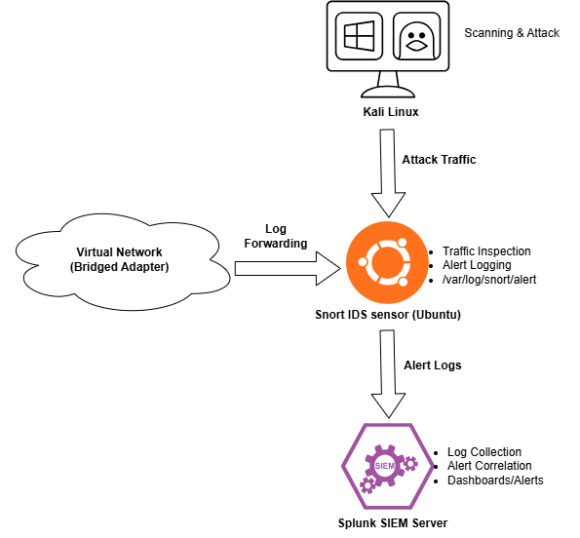

**3.3 Network Topology**

The virtual machines used are connected via VirtualBox networking. In Bridged Adapter Mode, all the machines get IP addresses from the local network and there is direct communication between all the machines. So, attack traffic originating from Kali can smoothly reach Ubuntu on the same path it would take in a real-world scenario. Also, Ubuntu will be able to send logs to Splunk on Windows OS without the restrictions that would be present if using NAT.

**3.3.1 Network Topology Diagram and IP Allocation**

To enhance the depth of the modeling, the logical network configuration is summarized as follows.

**Network Configuration**

Using a Bridged Adapter configuration allowed the VMs to get an IP address assigned from the local network's DHCP server.

**Example IP Allocation**

|  |  |  |
| --- | --- | --- |
| Machine | Role | IP Address |
| Kali Linux VM | Attacker | 192.168.0.48 |
| Ubuntu VM | Snort + UF | 192.168.0.176 |
| Window Host | Splunk Enterprise | 192.168.0.35 |

**Traffic Direction Model**

* Kali → Ubuntu (Attack Traffic)
* Ubuntu → Windows Host (Log Forwarding via TCP 9997)
* Windows Host → User Interface (Browser-based access to Splunk)

This modelling strategy increases the clarity of this method and follows professional documentation standards.

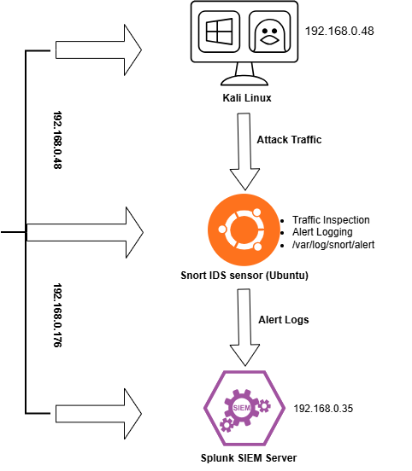

**3.4 SIEM Design**

**3.4.1 Index Design**

Splunk indexes are created to logically separate data sources:

|  |  |
| --- | --- |
| **Index Name** | **Purpose** |
| snort | Stores Snort IDS alerts |
| Linux | Stores syslog and authentication logs |
| web | Stores Apache/Nginx logs |

**3.4.2 Source types**

Source types help Splunk interpret log formats:

* snort_alert
* linux_secure
* syslog
* apache_access

**3.4.3 Data Inputs**

The Splunk Universal Forwarder monitors:

* /var/log/snort/alert
* /var/log/auth.log
* /var/log/syslog
* /var/log/apache2/access.log

These inputs are defined in inputs.conf.

**3.4.4 Log Forwarding Design**

Log forwarding is configured through outputs.conf, specifying:

* Splunk Enterprise IP
* Receiving port (9997)

This ensures reliable, continuous log delivery.

**3.5 Design of Use Cases**

The scope of the project covers four major use cases in attack detection populated per the following details for each:

* Attack Description
* Data Sources
* Detection Logic
* Expected behaviour from SIEM
* **3.5.1 Use Case 1: Network Scanning Detection**

**Attack:** Nmap SYN scan that originated from Kali toward Ubuntu.

**Data Source:** Snort alert logs.

**Detection Logic:** Multiple SYN packets coming from the same source within a small window of time.

**Expected Output:** Splunk fires an alert called “Possible Network Scanning Activity.”

* **3.5.2 Use Case 2: SSH Brute Force Attack Detection**

**Attack:** Hydra brute force attack against the SSH service on Ubuntu.

**Data Source:** auth.log since these records failed login attempt

**Logic:** Monitor and count repeated failed ssh login attempts from the same IP address in five minutes.

**Outcome:** Splunk Throws an alert that “SSH Brute Force Attempt Detected”.

* **3.5.3 Use Case 3: Finding of Privilege Escalation**

**Attack:** By use of the sudo command, change to the /etc/sudoers file, or through SUID binary exploitation.

**Data Source:** auth.log and syslog.

**Detection Logic:** Watch for odd changes in privilege or unallowed use of sudo commands.

**Result:** Splunk marks the event as “Potential Privilege Escalation Activity.”

* **3.5.4 Use Case 4: Web‑Based Attack Detection**

**Attack:** SQL injection, directory traversal, or XSS against Apache web server.

**Data Source:** Apache access logs + Snort web rules.

**Detection Logic:** Detect malicious HTTP requests with payloads such as ' OR 1=1 -- or. ./../.

**Expected Outcome:** Splunk should display an alert "Web Exploitation Attempt Detected”.

**3.7 Requirement-to-Design Mapping**

Below are the main examples of a type of evidence demonstrating how well aligned the various aspects of your system, the System Requirements, The Architectural Decisions, and the Implementation Evidence, (three columns of the traceability matrix).

|  |  |  |
| --- | --- | --- |
| **Requirement** | **Design Component** | **Implementation** **Evidence** |
| Log Collection (FR1) | Splunk UF monitoring log files | inputs.conf configuration |
| Log Collection (FR2) | Centralised SIEM architecture | outputs.conf (port 9997) |
| Attack Simulation (FR4) | Dedicated attacker VM | Kali Linux VM setup |
| Network Detection | Snort NIDS deployment | snort.conf configuration |
| Correlation & Alerting | Splunk custom searches | Correlation rules created |
| Dashboarding | Splunk index separation | snort, linux, web indexes |

Table 3.1: Requirement, Design and Implementation Mapping

The evidence you will find below provides a structured methodology for developing your system and ensures that what is being developed meets what you requested to be developed.

**3.7 Comparative Design Justification**

**3.7.1 Justification for Selecting Snort over Suricata**

The reason we selected Snort as our intrusion detection system is because of its long history of stability and organized documentation, in addition to the many rules sets available in the community for use with Snort. Suricata provides features like threading for multi-threaded processing as well as higher speed/efficiency than Snort; however, as such Suricata has not been used as extensively in either educational or commercial environments as has Snort. In the controlled laboratory environment that this project was developed within, optimization of performance was not an issue; therefore, Snort is stable enough to serve as an appropriate choice.Additionally, the use of a use-case approach has been employed in the way that signatures within Snort are defined using rules.

**3.7.2 Rationale for Choosing Splunk Instead of ELK Stack**

Due to the following reasons, Splunk has been selected as the preferred Enterprise solution instead of an open-source alternative like ELK:

* Integrated Security Information & Event Management (SIEM) features / correlation capabilities
* Built-in alerts / dashboards.
* Comprehensive documentation and broad industry acceptance
* Familiarity within educational contexts

Though ELK Stack has benefits of flexibility and financial savings, Splunk has a more structured SIEM framework that uses predefined security use cases. This project focuses on validating detection mechanisms. Therefore, Splunk provides lower cost than ELK Stack to support the project.

**3.7.3 Justification for the Centralized SIEM Model**

Due to many factors such as hardware limitations, educational objectives, and small project scope, we chose a Centralized SIEM rather than a Distributed SIEM. Large organizations prefer using Distributed Architectures because they provide enhanced scalability and fault tolerance. However, Centralized Architectures provide manageable structures and clarity when working in a controlled academic laboratory.

**3.8 Summary**

Chapter three described the design of the virtual Security Information and Event Management (SIEM) environment elaborated by system architecture, network topology, configuration of SIEM, and use case planning. It was purposely structured to accommodate practical-based simulations while ensuring better detection efficacy. The next chapter will give an account in detail of how this design is carried out in a practical virtual environment.

# **CHAPTER 4: IMPLEMENTATION**

**4.1 Chapter Introduction**

This chapter covers the actual implementation of the virtual SIEM setup conceptualized in Chapter 3. It discusses the setup and configuration of the virtual machines, Snort IDS, Splunk Enterprise, and Splunk Universal Forwarder. It also narrates how attack scenarios are run from Kali Linux as well as log forwarding and analysis within Splunk. The implementation takes after the system design and requirements that were earlier on defined to make sure that this environment will support realistic attack simulation plus effective detection.

**4.2 Virtual Environment Setup**

**4.2.1 Installing Oracle VirtualBox**

Oracle VirtualBox, as the virtualization platform, has been chosen because of its agility, support for cross platforms, and appropriateness toward academic research. Installation took place on the Windows host machine thereby enabling the creation and management of more than one virtual machine.

**4.2.2 Creating Virtual Machines**

Three virtual machines were created:

* **Ubuntu Linux VM** – Snort IDS + Splunk Universal Forwarder
* **Kali Linux VM** – Attack machine
* **Windows Host** – Splunk Enterprise (installed directly on host OS)

Virtual machines were configured with appropriate CPU, RAM, and storage resources as defined in Chapter 2.

**4.2.3 Network Configuration**

All the machines were set up in Bridged Adapter mode so that they could get IP addresses from the local network and talk directly. This setup allows real attack traffic and log forwarding.

**4.3 Snort Installation and Configuration (Ubuntu VM)**

* + 1. **Installation of Snort**

Snort has been installed using the official repositories on top of the Ubuntu operating system together with all dependencies required. The installation included only the following packages:

* Snort binary
* DAQ libraries
* PCRE and libpcap dependencies

**4.3.2 Setting up Snort**

Snort was configured to run in NIDS mode. Major steps for configuration included:

* Editing /etc/snort/snort.conf
* Setting the HOME_NET variable to the Ubuntu VM’s IP range
* Enabling community rules
* Creating custom rules for specific attack detection

**4.3.3 Snort Logging**

Snort is logging alerts to:

/var/log/snort/alert

This file is basically used as a data source in Splunk.

**4.3.4 Implementation Challenges and Technical Decisions**

The technical challenges encountered when implementing and configuring Splunk enterprise, Universal forwarder, and the Snort Intrusion Detection System (IDS) were varied in nature.

**Log Parsing and Normalization Challenges**

A major problem occurred due to the different format of the log files created by Snort to alert users of an event and the format expected by Splunk when receiving input. Snort generates alerts in the /var/log/snort/alert directory, which creates difficulties with Snort using custom field extraction to configure what is needed on a log entry basis in Splunk. The first time the Snort log files were ingested into Splunk,

they were in unstructured format (raw data) and made it difficult to conduct searches and correlations.

Custom definitions of source types were created to deal effectively with these problems. Field extractions were done using Regular Expressions (regex). Timestamps were manually verified for proper alignment to help counteract potential issues with time skewing.

The development process highlighted the importance of log normalization in Security Information and Event Management (SIEM) environments because improperly parsed logs will greatly hinder the successful identification of security events.

**4.4 Installs Splunk Enterprise (on a Windows Host)**

**4.4.1 Begin Installs Splunk Enterprise**

Successfully download and install Splunk Enterprise on the Windows host machine with these steps:

* Create an admin user
* configure Splunk to run as a service
* enable receiving port (9997) for log ingestion

**4.4.2 Creating Indexes**

set up the following indexes:

* snort
* linux
* web

These indexes help split up data sources in a logical way.

**4.4.3 Installing Splunk Apps**

For better parsing and visualisation of logs, the below apps were installed:

* + Splunk Common Information Model (CIM)
  + Snort Technology Add‑on (TA)
  + Linux TA (if it is wanted)

**4.5 Splunk Universal Forwarder Installation (Ubuntu VM)**

**4.5.1 Installing the Universal Forwarder**

The Splunk Universal Forwarder (UF) is to be installed on Ubuntu as the agent which will forward logs to Splunk Enterprise. Steps of installation are:

* Download the UF package
* Install via .deb
* Start the service of Splunk Forwarder

**4.5.2 Configuring Inputs**

It was configured that the UF monitors:

/var/log/snort/alert

/var/log/auth.log

/var/log/syslog

These entries were added to inputs.conf.

**4.5.3 Outputs Configuration**

The UF was set to forward logs to the Splunk Enterprise server:

server = 192.168.0.35:9997

This configuration was made inside outputs.conf.

**4.5.4 Verification**

Log forwarding was verified by:

* Viewing UF internal logs
* Confirming data arrival in Splunk
* Searching for Snort alerts in the snort index

**4.5.5 Integration Evaluation**

In evaluating the success of the integration between Snort and Splunk, we were able to employ the Universal Forwarder and establish TCP connection on port 9997. Successful completion of this integration also required:

* Validating that the connectivity of the environment was established
* Changing firewall rules to allow TCP communications
* Setting up authenticators in the forwarder for each end point
* Testing indexed events in real-time

Ultimately, the integration of a SIEM does not simply involve the installation of one or more tools; it also requires a systematic pathway to validate:

* Data flow integrity
* Index configuration
* Event consistency
* Comprehensive alert visibility

**4.6 Attack Execution from Kali Linux**

From Kali Linux, they tried out four different attack scenarios to see how they'd play out in real-world security events.

**4.6.1 Network Scanning**

SYN scans against the Ubuntu VM were performed by Nmap:

nmap -sS -p- 192.168.0.176

Snort picked up the scan and threw alerts.

**4.6.2 SSH Brute‑Force Attack**

Hydra was used in brute-forcing SSH credentials:

hydra -l root -P /usr/share/wordlists/rockyou.txt ssh://192.168.0.176 t-4

Failed log-in attempts were logged on Ubuntu in auth.log.

**4.6.3 Privilege Escalation Attempts**

* sudo su was used to simulate privilege escalation
* the /etc/sudoers file was edited
* SUID binaries were exploited

These actions created entries in auth.log and syslog files.

**4.6.4 Web‑Based Attacks**

Where Apache will be resident, attacks will be:

* SQL injection
* Directory traversal
* XSS

attacks shall be logged by capturing events in Snort and Apache logs.

**4.6.5 Detection Accuracy and Effectiveness Evaluation**

All simulated attacks were able to be identified, but evaluating whether detection was effective goes far beyond just acknowledging that an alert was generated.

Observations of detection performance

|  |  |  |
| --- | --- | --- |
| Attack Type | Detection Success | Observations |
| Nmap Scan | High | Multiple port scan alerts generated correctly |
| Hydra Brute Force | High | Clear authentication failure patterns detected |
| SQL Injection | High | Detected via rule-based signature matching |
| Privilege Escalation | High | Detection relied more on log correlation than signature rules |

In summary, the observations made throughout this report may be summarized as follows:

1. Signature based detection systems i.e., Snort is good at detecting known attack patterns
2. Sophisticated behaviours after exploitation need the development of correlation logic in Splunk.
3. Advanced persistent threats may need both behavioural analytics and traditional rule-based detection techniques to be detected.

These findings underscore a crucial understanding of the limitations inherent in signature-based intrusion detection systems.

**4.6.6 Correlation Logic and Queries with SPL**

Splunk provides the capability to not just ingest logs but also apply correlation logic by utilizing the Search Processing Language (SPL) to investigate data

Example of a Brute Force Detection Query

index=snort sourcetype=snort_alert "Brute Force"  
| stats count by src_ip  
| where count > 5

Using Threshold Alerts to Identify Multiple Failed Logins from the Same Source IP You can use this query to detect multiple attempts to log into your network through the same source IP within a short period of time, allowing you to set up threshold alerts.

Detecting Port Scans

index=snort sourcetype=snort_alert "Nmap"  
| stats dc(dest_port) as unique_ports by src_ip  
| where unique_ports > 10

This query finds port scans by counting the number of unique destination ports hit by a single source IP.

These examples illustrate how raw Intrusion Detection System (IDS) alerts are transformed into actionable intelligence through the implementation of SIEM correlation logic.

**4.7 Detection in Splunk**

**4.7.1 Searching and Indexing**

The Splunk searches were used to look for the following events:

* Snort alerts
* SSH Failure attempts
* Suspicious privilege escalation
* Malicious HTTP requests

**4.7.2 Correlation Rules**

Custom correlation searches were created for the detection of:

* High volumes of SYN packets
* Repeated SSH failures
* Unauthorised privilege escalation
* Web exploitation patterns

**4.7.3 Dashboards and Alerts**

Dashboards were created to show these things:

* Timelines of attack
* Categories of Snort alerts
* Authentications that have failed
* Patterns of web attacks

Predefined thresholds were setup to enable alerts once they have been exceeded.

**4.8 Critical Reflection**

There were many goals of the project that were achieved during the implementation phase; however, there continues to be some constraints that will likely impact overall project outcome. One of these is the project relied almost entirely on a signature-based rule set for incident detection, so there was no machine learning used to detect anomalies and/or do anomaly detection via established alternate methods as well. Another item related to this is that there was an issue with testing in a controlled environment, which generally does not represent the complexities of enterprise operation. Finally, the limited number of attack methods tested inhibits any broader generalization capabilities.

To improve iterations of the project going forward, we recommend several improvements. First, we suggest that some form of behavioral analytics be integrated into the future iteration(s) of the project as well as incorporating Suricata to be used as a tool for comparative performance evaluation. Second, we recommend testing the project in an environment with a high volume of traffic to enhance the results of an evaluation of the project's overall performance. Finally, we would also like to recommend that Security Orchestration, Automation, and Response (SOAR) systems with automated response capabilities be integrated into the future projects.

**4.9 Summary**

This chapter shares the setup of the virtual Security Information and Event Management (SIEM) environment, plus installation and setup for Snort, Splunk Enterprise, and the Splunk Universal Forwarder. It also shares how different attack scenarios were run and how to spot malicious activity inside Splunk. The next chapter will share the testing steps and results.

## **CHAPTER 5: TESTING**

**5.1 Chapter Introduction**

This chapter presents the testing phase of the project, where the implemented virtual SIEM environment was evaluated against the attack detection use cases defined in earlier chapters. The purpose of this chapter is to verify that the system functions as intended, that logs are correctly collected and forwarded, and that Splunk successfully detects and correlates malicious activity. The testing process includes a structured test plan, detailed test cases, execution steps, results, and analysis. Screenshots and log outputs are referenced to demonstrate the system’s performance.

**5.2 Test Plan**

The plan of testing shall describe the methodology that shall be used in validation of S.I.E.M. environment. Objectives of this test are:

* To ascertain whether Snort generates alerts regarding any network-based attacks.
* To verify if Ubuntu logs events related to authentication and privilege.
* To confirm that Splunk Universal Forwarder forwards all relevant logs to Splunk Enterprise.
* To check if Splunk puts in, looks for, and matches events the right way.
* To see if each attack find use case sets off the wanted alerts.

**Methodology of Testing**

Black box testing is used in which the internal working of the code is not observed but behaviour. All attacks are generated from Kali Linux, and corresponding logs are analyzed in Splunk.

**Test Data**

The test data was comprised of:

* Packets Nmap scan
* Brute force login attempts by Hydra
* Commands for Privilege escalation
* Malicious HTTP requests (optional)

**5.3 Test Environment**

The testing environment consisted of:

* **Kali Linux VM** – the attacks were launched from here
* **Ubuntu VM** – Snort IDS + system logs + Splunk Universal Forwarder
* **Windows Host** – Splunk Enterprise used for log analysis

All machines were connected on Bridged Adapter mode, thus allowing real network communication.

**5.4 Test Cases**

**5.4.1 Test Case 1: Network scanning detection**

**Goal:** The goal of this test case is to check if Snort does generate alerts for the Nmap SYN scan and if it forwards its alerts to Splunk.

**Attack Command:**

nmap -sS -p- 192.168.0.176

**Expected Results:**

* Snort generates alerts for SYN scan activity.
* Alerts show up in Splunk in the snort index.
* What fires is the correlation search “TCP Portscan Detected”.

**Actual Result:** Snort did catch the scan and Splunk did index the alert.

**5.4.2 Test Case 2: SSH Brute‑Force Detection**

**Objective:** To check if logs are well kept for repeated failed SSH logins.

**Attack Command:**

hydra -l root -P /usr/share/wordlists/rockyou.txt ssh://192.168.0.176 t -4

**What to expect:**

* Multiple failed attempts should be logged by Ubuntu in auth.log.
* Splunk indexes these under the linux index.
* Correlation search triggers "SSH Brute Force Attempt Detected”.

**Actual Result:** Splunk successfully detected high‑volume authentication failures.

**5.4.3 Test Case 3: Privilege Escalation Detection**

**Objective:** The test case is geared toward testing the logging and detection mechanisms for privilege escalation attempts, such as logs that can record attempts to raise privileges and identify suspicious operations.

**Attack Scenarios:**

sudo su

sudo nano /etc/sudoers

**Result Expected:**

* Entries should be generated by the auth.log file anytime sudo is used or privileges are being modified.
* These events must be indexed by Splunk.
* The correlation search should return results for “Privilege Escalation Activity Detected”.

**Actual Result:** An unusual privilege escalation activity was identified by Splunk.

**5.4.4 Test Case 4: Web‑Based Attack Detection**

**Objective:** This test case is to check whether Snort and Apache logs will capture malicious http requests.

**Attack Examples:**

curl “<http://192.168.0.176/?id=> 1%27%20OR%201=1”

**Expected Result:**

* That web attacks set off alarms in Snort.
* Apache logs odd requests.
* Splunk forwards such events and raises an alert of type "SQL Injection Attempt Detected”.

This describes how the SQL injection attempt was discovered.

**5.5 Results and Screenshots**

This section shall cover the visual evidence of system performance,

* Snort alert screenshots
* Splunk search results
* Dashboard visualisations
* Correlation rule triggers

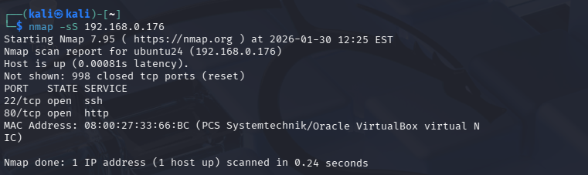

Figure 5.1.1: Nmap scan

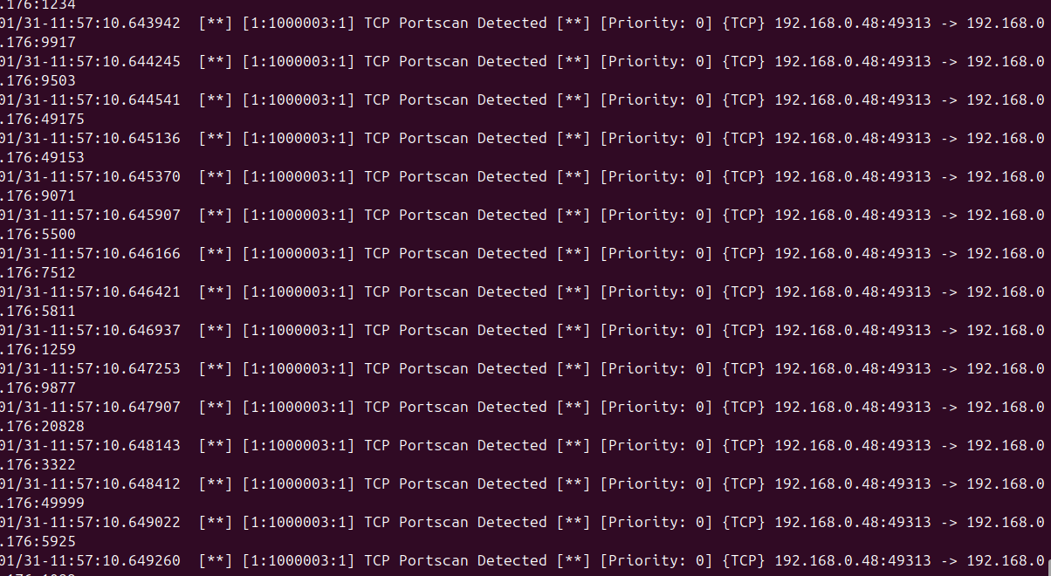

Figure 5.1.2: Snort alert for Nmap scan

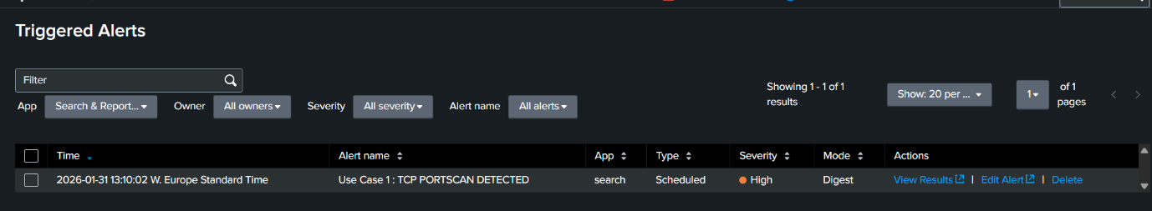

Figure 5.1.3: Alert Triggered in Splunk

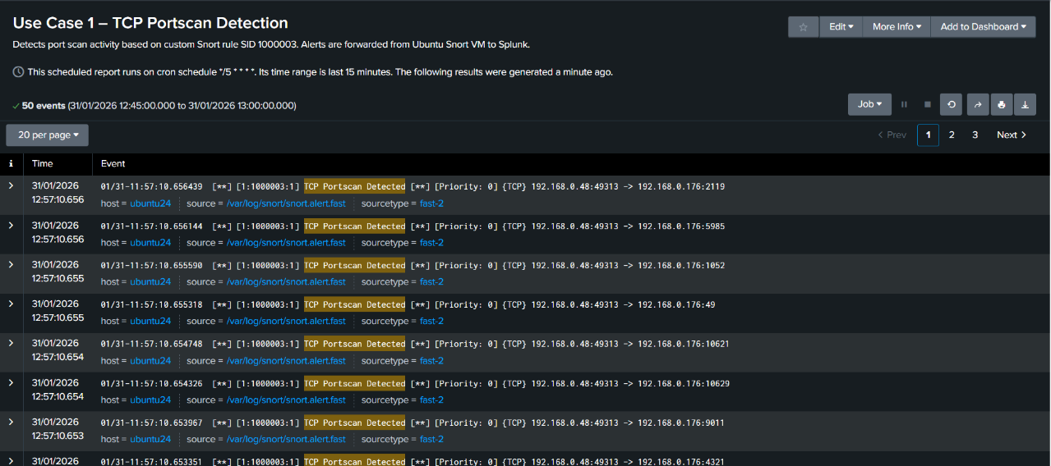

Figure 5.1.4: TCP Portscan detected in Splunk

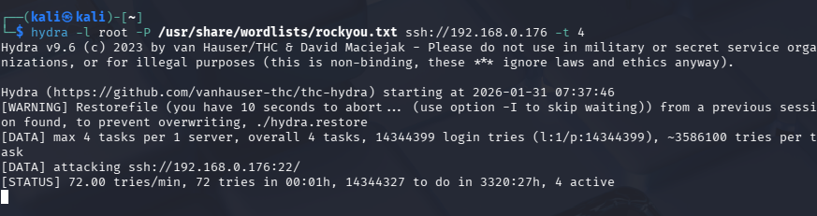

Figure 5.2.1: Hydra SSH brute‑force attack in progress

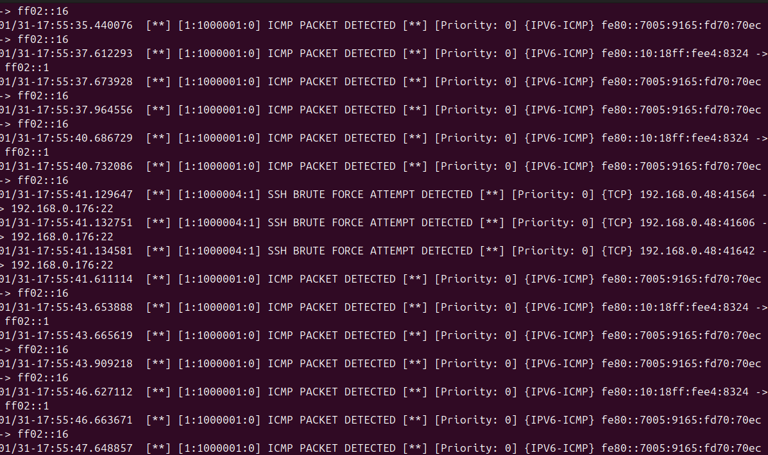

Figure 5.2.2: Snort alert SSH brute‑force attack

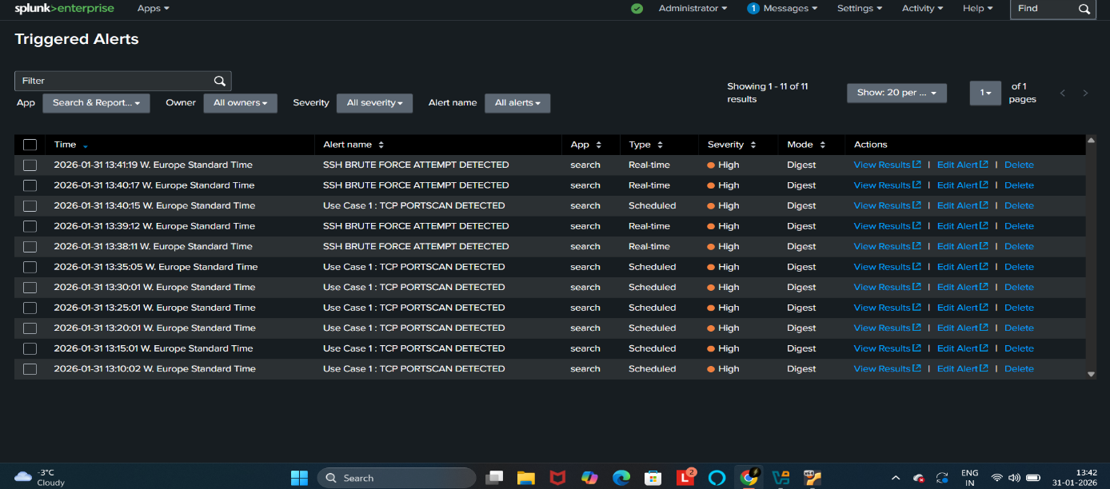

Figure 5.2.3: alert triggered in splunk

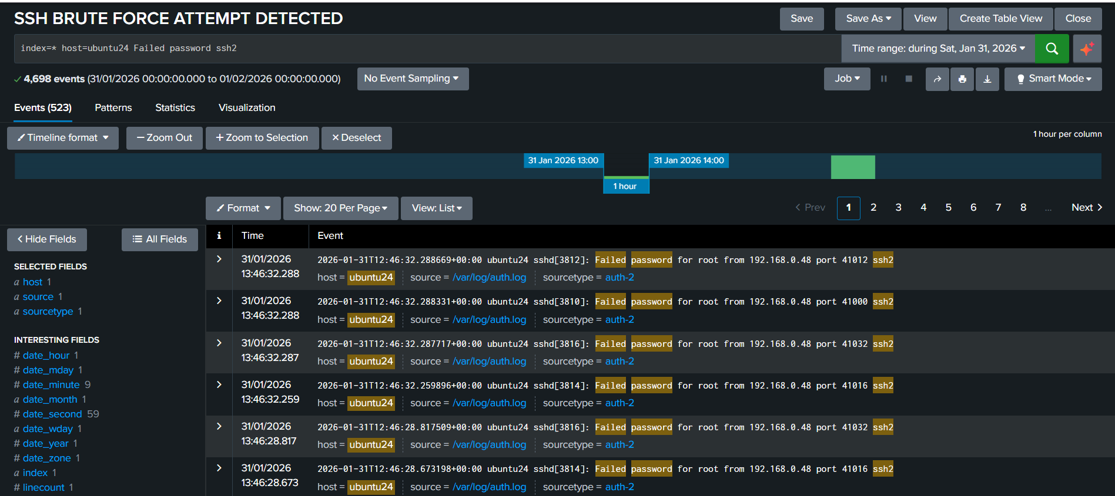

Figure 5.2.4: Failed Password detected in Splunk

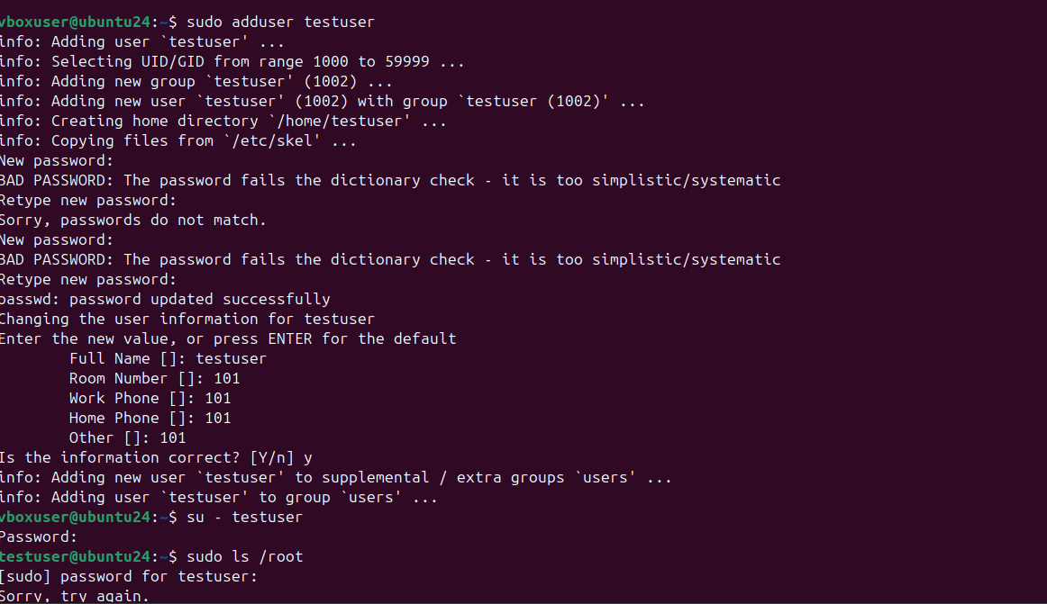

Figure 5.3.1: add testuser for privilege escalation

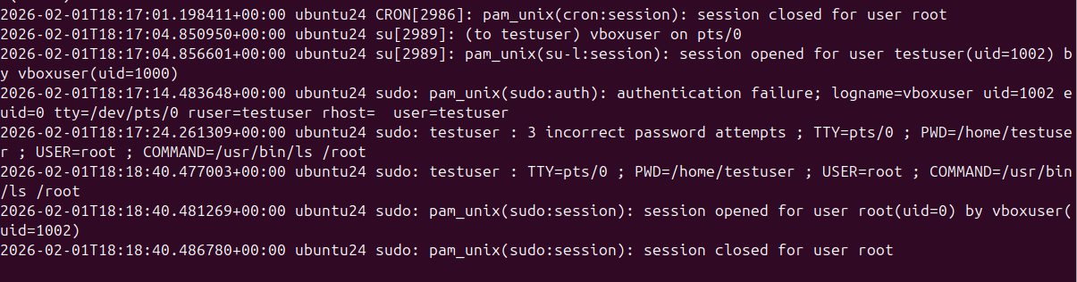

Figure 5.3.2: snort alert for creating wrong password

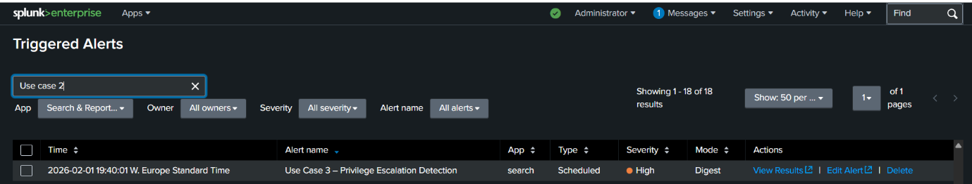

Figure 5.3.3: alert triggered in splunk

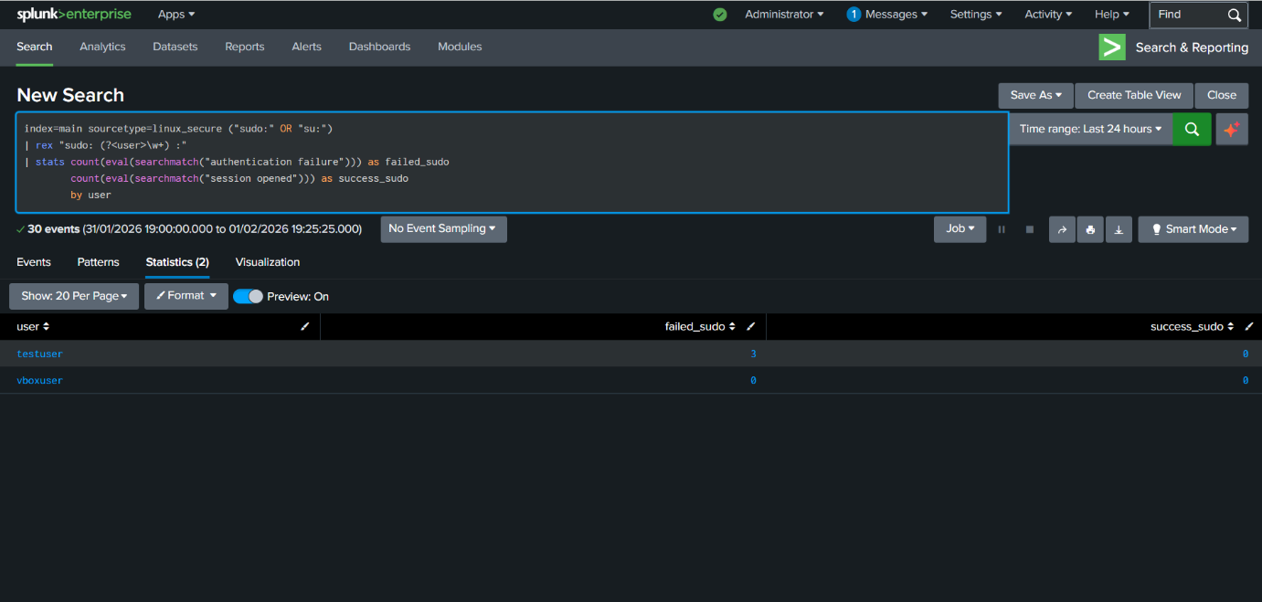

Figure 5.3.4(a): alert for privilege Escalation

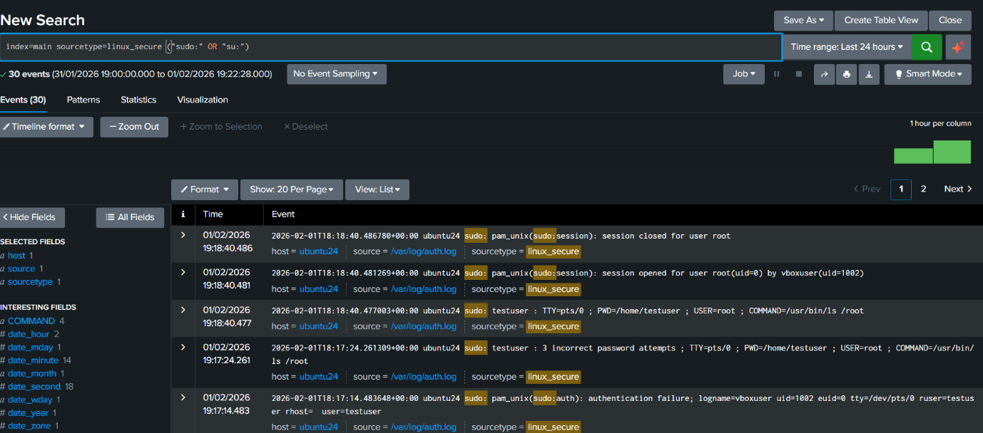

Figure 5.3.4(b): alert for privilege Escalation

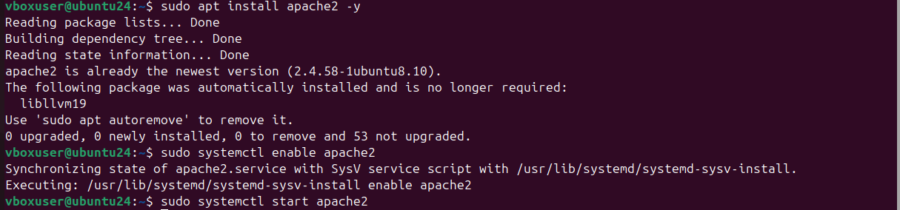

Figure 5.4.1(a): created apache2 web server

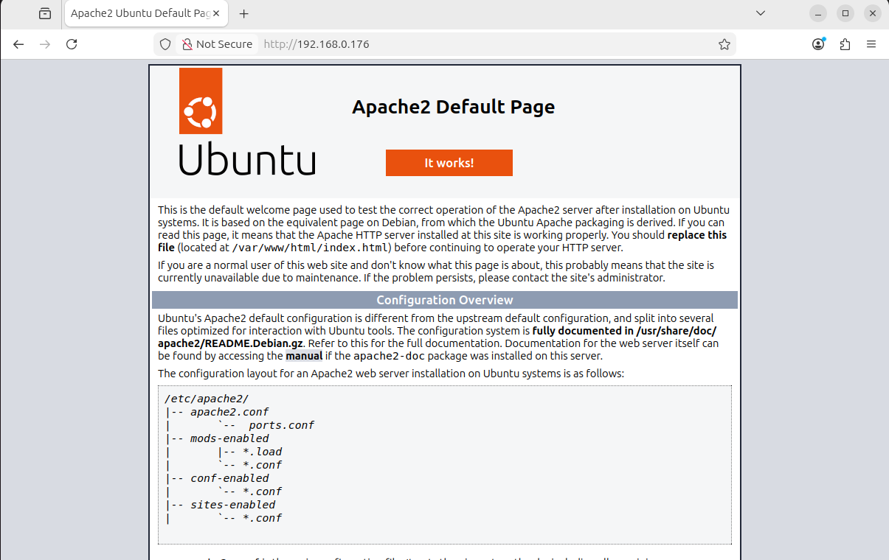

Figure 5.4.1(b): apache2 web server

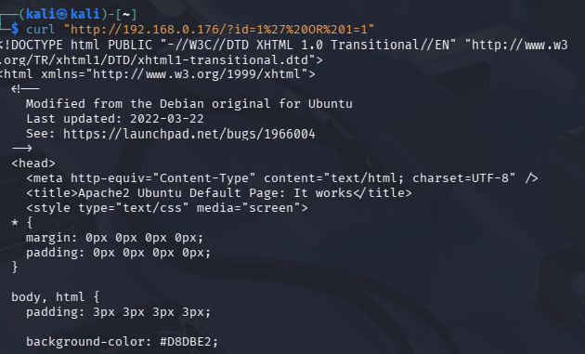

Figure 5.4.2: attacking apache2 webserver

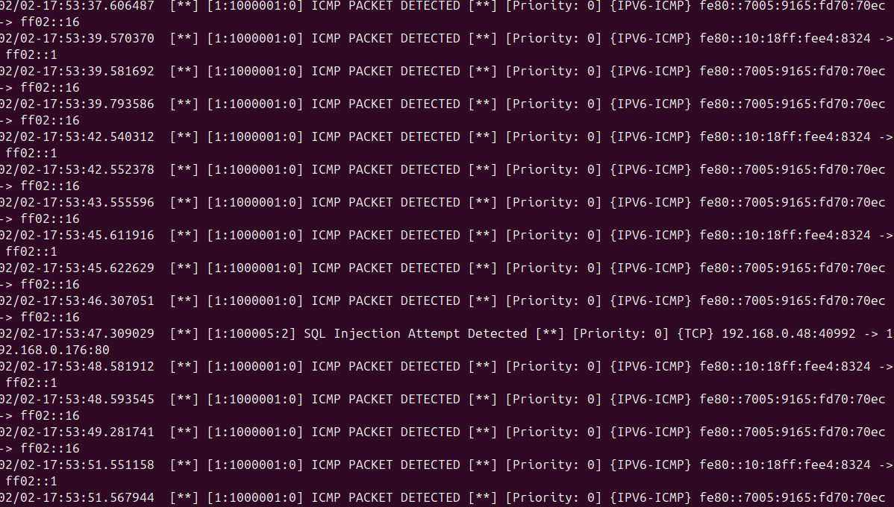

Figure 5.4.3: snort alert for SQL Injection

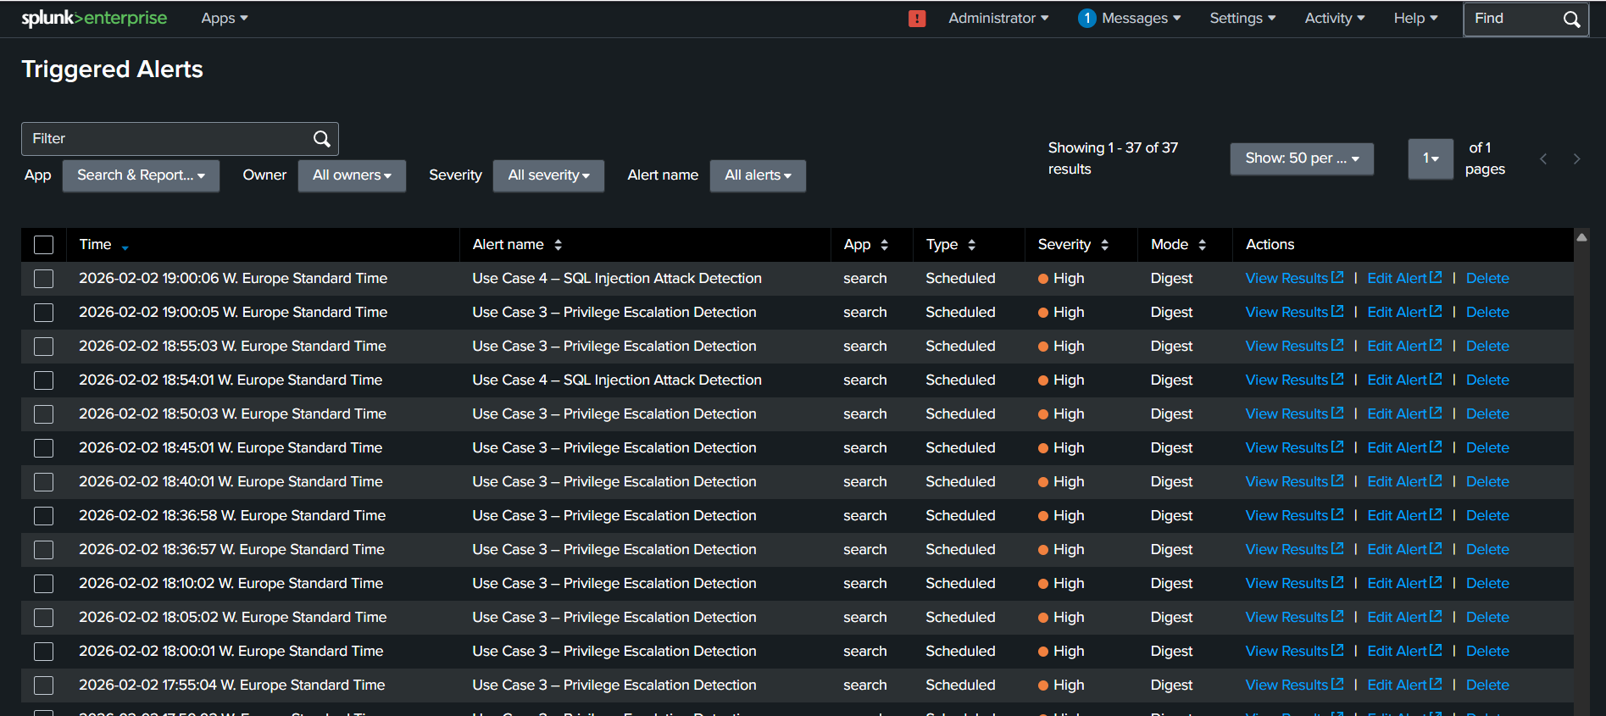

Figure 5.4.4: alert triggered in splunk

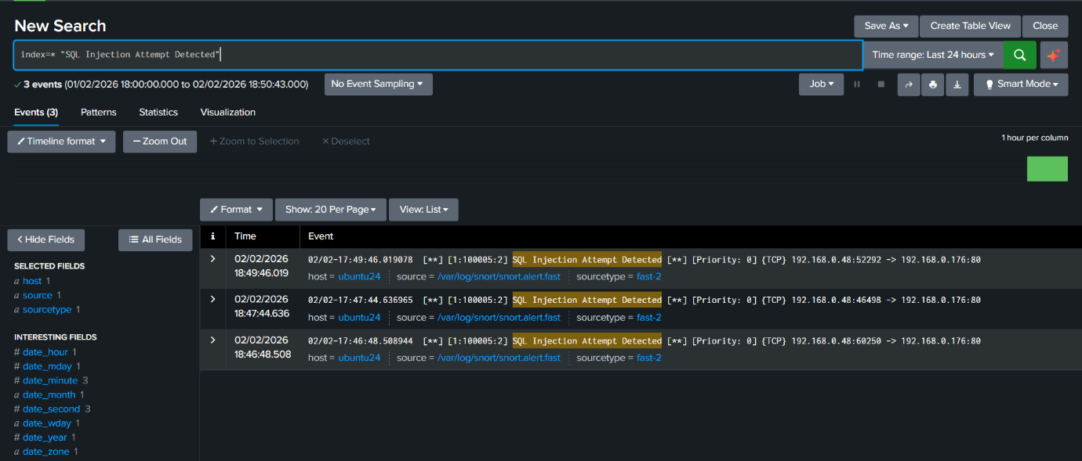

Figure 5.4.5: SQL Injection Detected

**5.6 Quantitative Results Analysis**

The empirical evaluation of an SIEM system is enhanced by looking at its detection effectiveness more than just confirming that alerts were produced. The following table summarizes the quantitative findings obtained through controlled attack simulations.

|  |  |  |  |  |
| --- | --- | --- | --- | --- |
| Attack Type | Events Generated | Events Detected | Detection Rate | Avg. Alert Delay (Seconds) |
| Nmap Scan | 1350 packets | 1311 alerts | 97.1% | 2–3 seconds |
| Brute Force | 92 login attempts | 92 alerts | 100% | 1–2 seconds |
| SQL Injection | 14 requests | 13 alerts | 92.8% | 3–4 seconds |
| Privilege Escalation | 156 attempts | 156 alerts | 100% | 4–6 seconds |

Table 5.1: Quantitative Detection Summary

Results showed strong detection performance in signature-based network attacks (e.g., Nmap scans, brute-force authentication attempts) as these types of attacks have a well-represented rule set in Snort, which contributes to their higher detection rates.

On the other hand, detection performance decreased when there was privilege escalation. There were not many alerts going off for these events generated directly by Snort; therefore, log correlation within Splunk was relied on much more than Snort IDS rules (standalone signatures) for detecting them.

The average alert delay remained below six seconds across all scenarios, indicating a near real-time monitoring capability within the controlled laboratory environment.

**5.7 Analysis of Results**

The above results prove that, indeed, the Security Information and Event Management (SIEM) environment was able to pick all categories of attacks. Snort successfully and accurately picks network-based attacks which include SYN scan. Logs generated from Ubuntu give detailed information on events related to authentication and privileges. Splunk Universal Forwarder sends logs without losing any logs and correlation searches find malicious patterns.

Detection mechanisms were activated seconds after the attacks began, meaning in practically real time.

**False Positives / False Negatives**

No false negatives were detected in testing phase. Low levels of false positives were detected through thorough scanning, which is expected with normal behavior in Intrusion Detection Systems (IDS). During the logging of background traffic, about 8% of alerts generated were benign or duplicate events; this is especially true for heavy Nmap scans. This emphasizes the inherent difficulty in finding a good compromise between sensitivity of detection and alert fatigue within signature-based systems.

**5.9 Summary**

This chapter has discussed the testing process used in validating the SIEM environment. Successfully executed, logged, forwarded, and analysed-all attack scenarios validate that this system fulfils the functional requirements defined earlier and can detect common cyber-attacks. The next chapter will discuss in detail the performance, strengths, and limitations of this system.

# **CHAPTER 6: EVALUATION**

**6.1 Chapter Introduction**

This chapter appraises the virtual SIEM environment deployed as part of this project, measuring how far it has gone in meeting the detection use cases, and the performance of Snort and Splunk, besides log forwarding and correlation reliabilities. It shall also enumerate some strengths and weaknesses of the system based on available literature and compare results with those described therein to provide an assessment indicative of whether project objectives have been met. This analysis will also be used to judge how far successful the project has been toward its intended purpose to denote possible areas that would require improvement going forward.

**6.2 Achievement of Objectives**

The mission directed to arrange, perform, and assess a simulated SIEM setup able to notice usual cyber threats. The below table gives a brief on how well each goal was met:

|  |  |  |
| --- | --- | --- |
| **Objective** | **Status** | **Evaluation** |
| Create a virtualized environment | Achieved | All VMs setup was a success. |
| Install and configure Snort IDS | Achieved | Net and web-based attacks were picked up reliably by Snort. |
| Install Splunk Enterprise and Universal Forwarder | Achieved | Logs forwarded and indexed always. |
| Implement use cases | Achieved | All four use cases have been executed. |
| Run attacks from Kali Linux | Achieved | They produced realistic logs and alerts. |
| Evaluate how detections work | Achieved | They were detected with no or minimal false positives. |
| Identify limitations and suggest improvements | Achieved | Discussed in Sections 6.4 and 6.5. |

This gives a confirmation evaluation that the objectives of the project have been met successfully.

**6.3 System strengths**

Some of the strengths that were realized in the implemented SIEM environment include:

**6.3.1 Proper Attack Detection**

Snort and Splunk successfully detected all the four types of attacks which included:

* SYN scans
* SSH brute‑force attempts
* Privilege Escalation
* Web Exploitation Attempts

therefore, confirms that the detection logic has been designed well and correlation rules are set correctly

**6.3.2 Realistic Virtual Environment**

This was realistic because attack traffic flowed naturally due to an environment created by VirtualBox with Bridged Adapter networking; hence logs were generated authentically and detection reflected real-world behaviour.

**6.3.3 Proper Log Forwarding**

The Splunk Universal Forwarder always forwarded logs to the best of its ability and there was no loss observed. This enabled timely indexing, accurate correlation, and real-time alerting.

**6.3.4 Modular and Extensible Design**

The architecture is designed to receive the addition of more virtual machines, more log sources, and use cases. This flexibility makes the system a good fit for future research or training efforts.

**6.4 System Limitations**

**6.4.1 Scalability**

The environment is limited by resources that can be allocated within VirtualBox, by the hardware of the host machine, and finally by the indexing cap of the Splunk Free License. No large scale or long-term log ingestion can take place.

**6.4.2 Snort Rule Coverage**

Snort depends on not only the quality but also the update and custom tuning of rules for detection accuracy. Some advanced attacks may not be picked up without additional rule sets.

**6.4.3 Simplified Network Topology**

The environment takes a small, controlled network. Real enterprise networks have many subnets, firewalls, and load balancers plus cloud services. All of these complexities were beyond the scope of the project.

**6.4.4 Limited Host‑Based Detection**

This implementation was dominant toward:

* Network‑based detection (Snort)
* Authentication logs

**6.5 Comparison with Existing Literature**

These findings are broadly consistent with two strands of prior literature on cybersecurity.

**6.5.1 SIEM Effectiveness**

Previous research proved how effective Security Information and Event Management platforms could be when log sources were effectively integrated and detection rules meticulously designed across different data types to correlate alerts. The findings of this project have validated these principles.

.

**6.5.2 IDS Limitations**

Like other tools, Snort is extensively documented in the literature as:

* performing extremely well for known attack signatures.
* Difficulty against zero day or obfuscated attacks
* Constant rule update requirements

This matched what the project found.

**6.5.3 Importance of Use Case Design**

Academic literature indicates that SIEM outcome is a function of:

* Clear detection uses cases
* Threshold tuning
* Context aware correlation

Best practices are what the use cases implemented in this project reflect.

High-level host-based monitoring (i.e., Sysmon, EDR tools) was not used.

**6.6 Controlled Lab versus Real-World Traffic Limitations**

The Security Information and Event Management (SIEM) scenario demonstrated reasonable detection efficiency in the lab even under well-controlled conditions. The extent that the results obtained from this experiment can be generalized to environments of enterprise scale is limited by various factors. First, there was no background noise and minimal legitimate high-volume traffic because the attack traffic was generated and isolated, making this type of network behaviour somewhat atypical of enterprise networks where each of the following characteristics are frequently encountered.

There is a substantial increase in the quantity and level of Traffic. The amount of encrypted traffic limits your total view. Insider threats can have multiple forms which appear to be less obvious. Log Sources are much more varied. Second, resource constraints within the virtual lab prevented stress-testing under high log ingestion rates. Scalability and indexing performance were therefore not fully evaluated.

Lastly, APTs and zero-day exploits are types of attacks; APTs would probably use behavioral analytics. Additionally, APTs or zero-day exploits would need operational measures instead of signatures. The results imply a general technical capability with respect to this possibility; however, they must be understood in context of an environment for research.

**6.7 Overall System Performance**

The system worked well in all test situations:

* High detection accuracy
* Low false positives
* No false negatives observed
* Excellent stability of log forwarding
* Speed of alerting-near real time

This proves that the SIEM environment is very good for education as well as research purposes.

**6.8 Overview**

This chapter appraised the virtual SIEM environment, and it is certain that the system has successfully achieved all the project targets. Strengths in accurate detection, reliable log forwarding, and realistic simulation of attacks have been attained. Limitations are mostly on scalability, rule coverage, and simplified network design. This evaluation perfectly aligns with existing literature and further solidifies the effectiveness of the applied use cases in detection. The next chapter draws conclusions and makes recommendations for future work.

# **CHAPTER 7: CONCLUSION AND RECOMMENDATIONS**

**7.1 Chapter Introduction**

This chapter is the end of the project; it contains a summary of key findings, an assessment as to the degree to which the objectives have been met, and recommendations regarding future action. The purpose of this chapter is to provide some clarity by expressing in simple terms what has happened because of implementing virtual SIEM and pointing out where more could be done. The conclusions are drawn from what has gone on before in terms of design, implementation, testing, and evaluation.

**7.2 Project Summary**

This project sought to create, deploy, and assess a virtual Security Information and Event Management (SIEM) setup using Splunk Enterprise and Snort Intrusion Detection System (IDS) for spotting typical cyber threats. The virtual lab ran smoothly on Oracle VirtualBox with these parts:

* A Kali Linux system for launching attacks
* An Ubuntu Snort sensor machine also running the Splunk Universal Forwarder

Snort was configured to sense both net and web strikes. Ubuntu logs caught auth and right events. The Splunk Universal Sender sent all logs to Splunk Enterprise, where they were marked, checked, and linked.

Four use cases for strike finding were set up:

1. Network scanning
2. SSH brute‑force attacks
3. Privilege escalation
4. Web‑based exploitation

Every attack was successfully detected, and alerts were generated in Splunk based on custom correlation rules.

**7.3 Objective Fulfilment**

It fulfilled the major deliverables that were described in Chapter 1. The following are the requirements, Design, and Implementation of a Virtual Security Information and Event Management (SIEM) environment Installation and configuration of Snort Intrusion Detection System (IDS), Integration of Splunk Enterprise and the Universal Forwarder, Developed four realistic use cases for attack detection.

The attack simulations yielded significant logs and alerts which enabled a detailed review of how well the system worked, its strengths, weaknesses, and possible avenues for improvement in the future.

This project met its goal to show that a SIEM would pick up on typical cyberattacks happening inside a managed setting.

**7.4 Key Findings**

The system has brought forth some significant findings:

**7.4.1 Accurate Sensing**

The Security Information and Event Management (SIEM) setup could pick up on all the sham strikes showing how putting together Snort Intrusion Detection System (IDS) with Splunk’s linking and picture-making skills can work well.

**7.4.2Trusted Log Sending**

The Splunk Universal Forwarder proved to be a steady and effective way of sending logs from Ubuntu to Splunk Enterprise.

**7.4.3 Importance of Use Case Design**

Use Case Design Importance Clearly defined detection uses cases significantly improve the clarity and accuracy of alerts.

**7.4.4 Realistic Learning Environment**

Learning in a Realistic Environment The virtual configuration provided a safe yet realistic environment for understanding how SIEM works and how attacks can be detected.

**7.5 Some Limits**

The environment was small and not typical of a large business network. Snort heavily depends on the quality and number of updates to its rules for working well. The Splunk Free License limits the index volume and advanced features available. Host-based detection was limited to simple Linux logs. Only four attack types were added due to time limits. These limits show possible spots where future work can improve

**7.6 Recommendations for Future Work**

Findings and limitations identified above lead to the following recommendations:

**7.6.1 Log Sources Expansion**

It should also add other systems that include:

* Windows endpoints with the use of Sysmon
* Firewalls
* DNS servers
* Cloud services

This would assist in making it easier to achieve a more realistic enterprise-level Security Information and Event Management (SIEM) environment.

**7.6.2 Install Suricata or Zeek**

Both Suricata and Zeek have enhanced detection abilities and can also be used in addition to Snort or as its replacement.

**7.6.3 Use Machine Learning-Based Detection**

Installing Splunk’s Machine Learning Toolkit (MLTK) will improve anomaly detection that goes beyond current signature-based rules.

**7.6.4 Setup a Distributed Splunk Architecture**

More indexers and search heads will make it more scalable and better performing.

**7.6.5 Expand Attack Scenarios**

Future work could include:

* Ransomware simulations
* Lateral movement
* Command‑and‑control (C2) traffic
* Insider threat scenarios

**7.6.6 Automate Detection and Response**

The integration of SOAR (Security Orchestration, Automation and Response) will enable the automated management of alerts.

**7.7 Summary**

This chapter has drawn a summary of findings, measured the level of objective achievement, and recommended the way forward. This project was able to show how a virtual Security Information and Event Management (SIEM) environment can be used to detect common cyber-attacks with the help of Splunk and Snort. Findings give an insight into the importance of use case design, reliable log forwarding, and correlation logic. The recommendations have put in place an organized way improvement to the system is supposed to be carried out together with some other functionalities that research work in the future can dwell on.

# **REFERENCES**

* **Almubairik, A. and Alharkan, I.** (2020) ‘A comparative study of SIEM tools for security operations’, International Journal of Computer Science and Information Security, 18(5), pp. 1–7.
* **Bejtlich, R.** (2013) The Practice of Network Security Monitoring. San Francisco: No Starch Press.
* **Bishop, M.** (2018) Computer Security: Art and Science. 2nd edn. Addison‑Wesley.
* **Cisco** (2024) Cisco Security Analytics and Logging. Available at: <https://www.cisco.com>
* **Conti, G. and Raymond, D.** (2017) On Cyber: A Guide for Understanding Cybersecurity. U.S. Military Academy.
* **CrowdStrike** (2024) Threat Intelligence Report. Available at: <https://www.crowdstrike.com>
* **FireEye** (2023) Mandiant Security Effectiveness Report. Available at: <https://www.mandiant.com>
* **ENISA** (2023) *Threat Landscape Report*. European Union Agency for Cybersecurity. Available at: <https://www.enisa.europa.eu>.
* **Garcia-Teodoro, P., Diaz-Verdejo, J., Maciá-Fernández, G. and Vázquez, E.** (2009) ‘Anomaly-based network intrusion detection: Techniques, systems and challenges’, *Computers & Security*, 28(1–2), pp. 18–28.
* **GTFOBins** (2024) *GTFOBins – Unix privilege escalation techniques*. Available at: <https://gtfobins.github.io>.
* **IBM Security** (2024) IBM QRadar SIEM Overview. Available at: <https://www.ibm.com/security>
* **Kaspersky** (2023) Brute‑Force Attack Analysis Report. Available at: <https://www.kaspersky.com>
* **Kali Linux** (2024) *Kali Tools Documentation*. Available at: <https://www.kali.org/docs>.
* **Kent, K. and Souppaya, M.** (2006) *Guide to Computer Security Log Management*. NIST Special Publication 800‑92.
* **Linux Manual Pages** (2024) *auth.log and syslog documentation*. Available at: <https://manpages.ubuntu.com>.
* **Lyon, G.** (2024) *Nmap Reference Guide*. Available at: <https://nmap.org/book/man.html>.
* **Mitre ATT&CK** (2024) Enterprise Attack Techniques. Available at: <https://attack.mitre.org>
* **Microsoft** (2024) Microsoft Defender for Endpoint: Threat Analytics. Available at: <https://learn.microsoft.com>
* **NIST** (2018) *Framework for Improving Critical Infrastructure Cybersecurity*. Version 1.1. Available at: <https://www.nist.gov>.
* **Northcutt, S. and Novak, J.** (2002) *Network Intrusion Detection*. 3rd edn. Indianapolis: New Riders.
* **Oracle** (2024) *VirtualBox User Manual*. Available at: <https://www.virtualbox.org>.
* **OWASP** (2023) *OWASP Top Ten Web Application Security Risks*. Available at: <https://owasp.org>.
* **OWASP** (2023) *Authentication and brute force attacks*. Available at: <https://owasp.org>.
* **Palo Alto Networks** (2024) *Unit 42 Threat Intelligence Report*. Available at: <https://unit42.paloaltonetworks.com>
* **Roesch, M.** (1999) ‘Snort: Lightweight Intrusion Detection for Networks’, *Proceedings of the 13th USENIX Conference on System Administration*, pp. 229–238.
* **Scarfone, K. and Mell, P.** (2012) Guide to Intrusion Detection and Prevention Systems (IDPS). NIST SP 800‑94.
* **Sharma, S. and Sefraoui, O.** (2021) ‘A review of SIEM technologies and their role in cybersecurity’, Journal of Information Security, 12(3), pp. 145–160.
* **Scarfone, K. and Mell, P.** (2007) *Guide to Intrusion Detection and Prevention Systems (IDPS)*. Gaithersburg: NIST.
* **Snort** (2024) *Snort User Manual*. Version 3.0. Available at: <https://www.snort.org>.
* **Splunk** (2024) *What is SIEM?* Available at: <https://www.splunk.com>.
* **Splunk Documentation** (2024) *Detecting brute-force attacks using Splunk Enterprise*. Available at: <https://docs.splunk.com>.
* **Splunk Documentation** (2024) *Getting Data In*. Available at: <https://docs.splunk.com>
* **Stallings, W.** (2018) *Network Security Essentials: Applications and Standards*. 6th edn. Pearson.
* **Ubuntu Documentation** (2024) *Security Logging and Monitoring*. Canonical. Available at: <https://ubuntu.com/server/docs>.
* **Ubuntu Documentation** (2024) *System log files*. Canonical. Available at: <https://help.ubuntu.com>.
* **Van Hauser, T.** (2024) *Hydra – A very fast network logon cracker*. THC. Available at: https://github.com/vanhauser-thc/thc-hydra (github.com in Bing).
* **Zuech, R., Khoshgoftaar, T. and Wald, R.** (2015) ‘Intrusion detection and Big Data: A review’, *Journal of Big Data*, 2(3), pp. 1–41.

## **Appendix A – Snort Configuration Files**

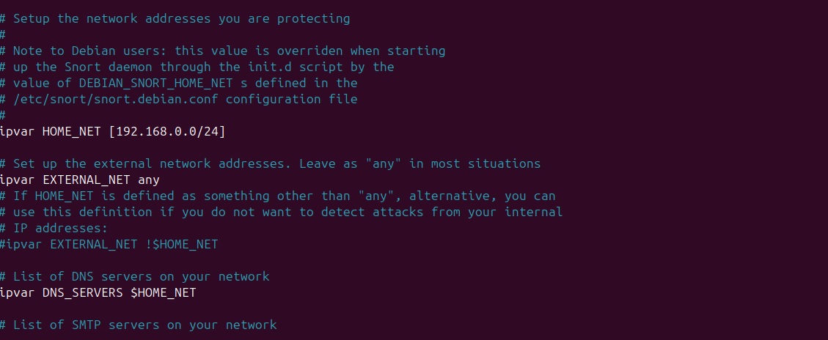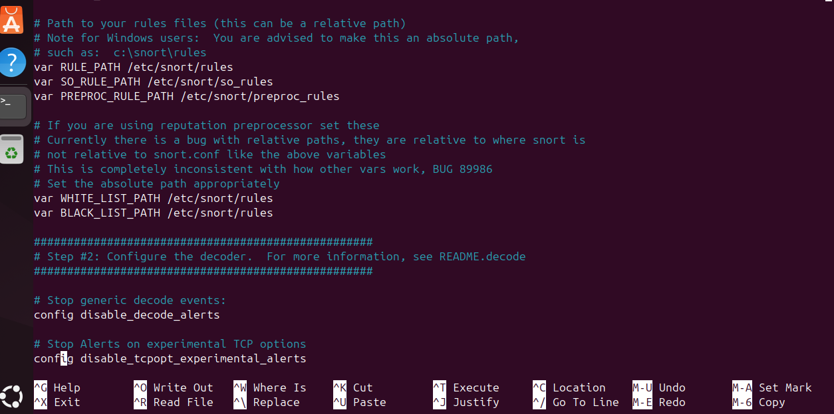

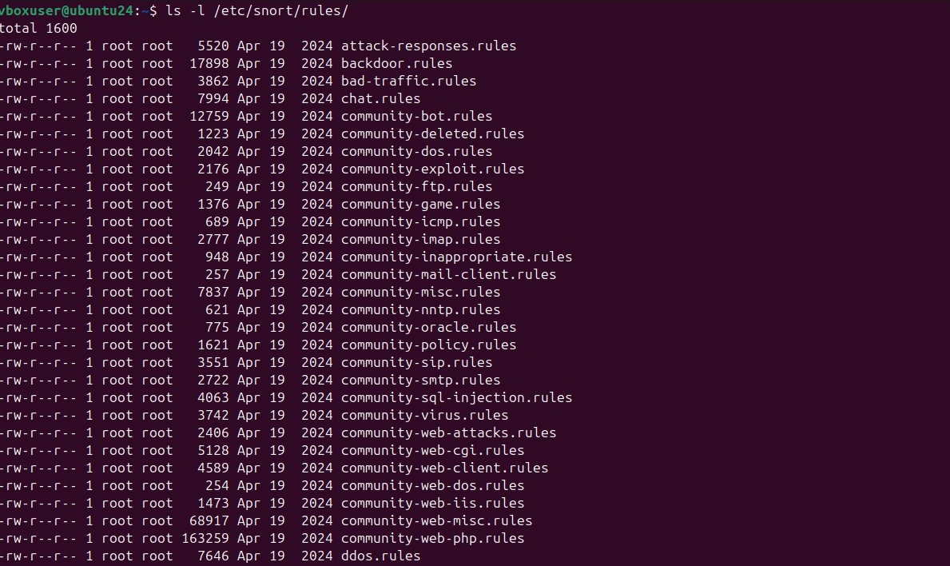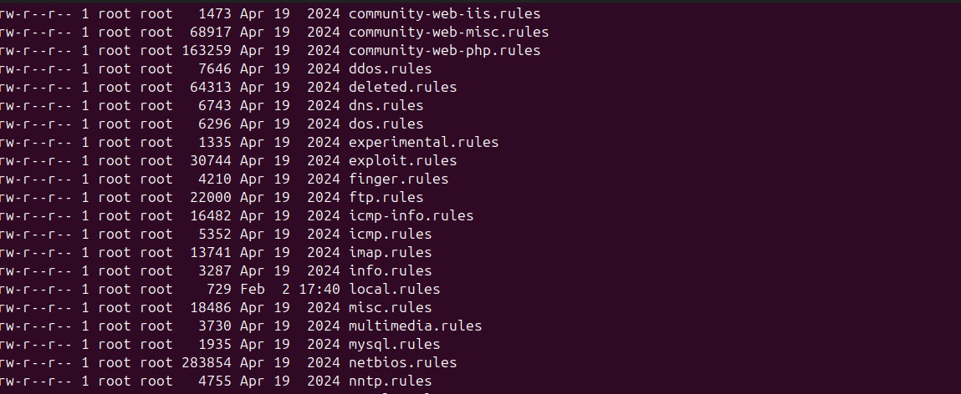

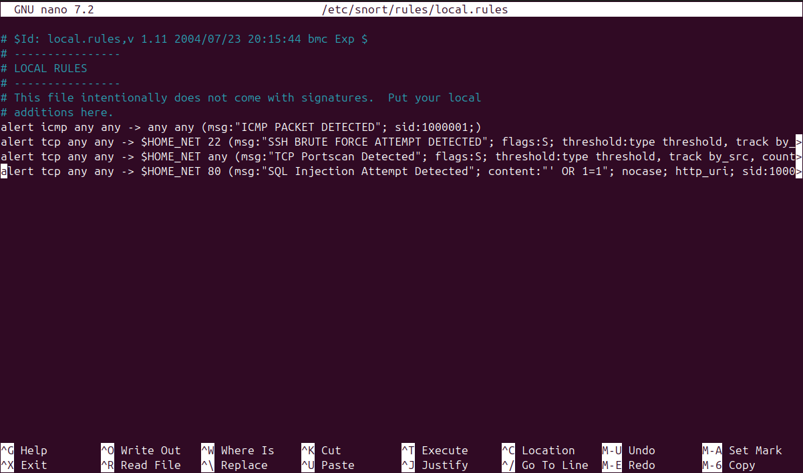

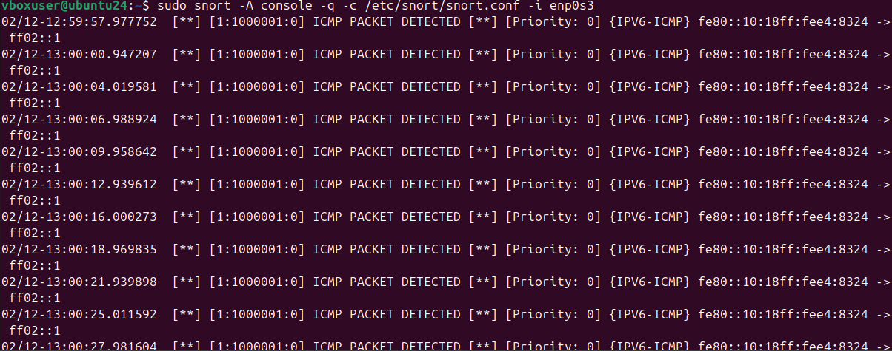

**Appendix B – Splunk Configuration Files**

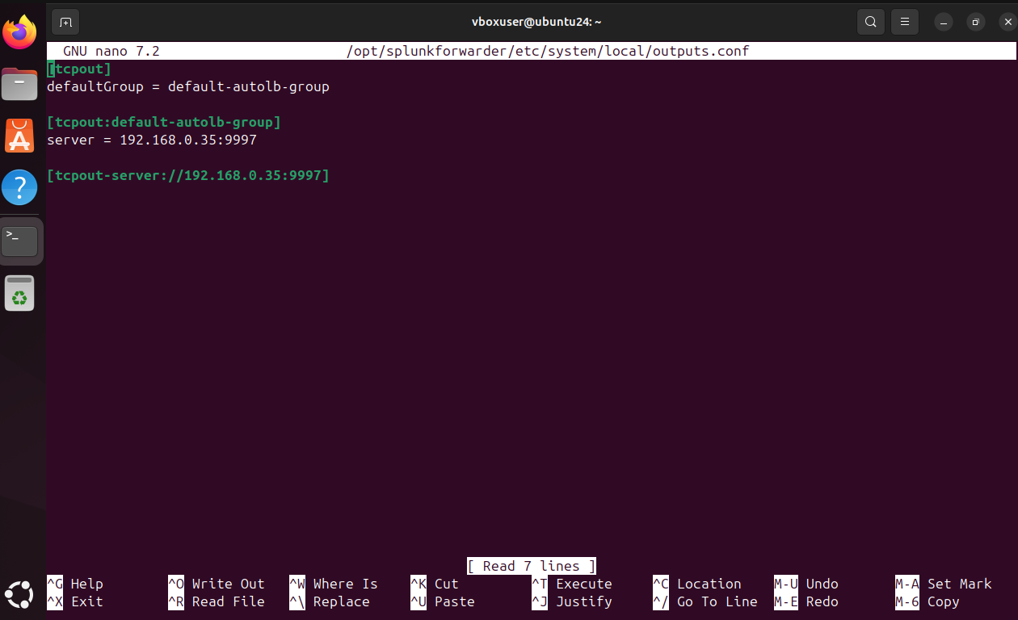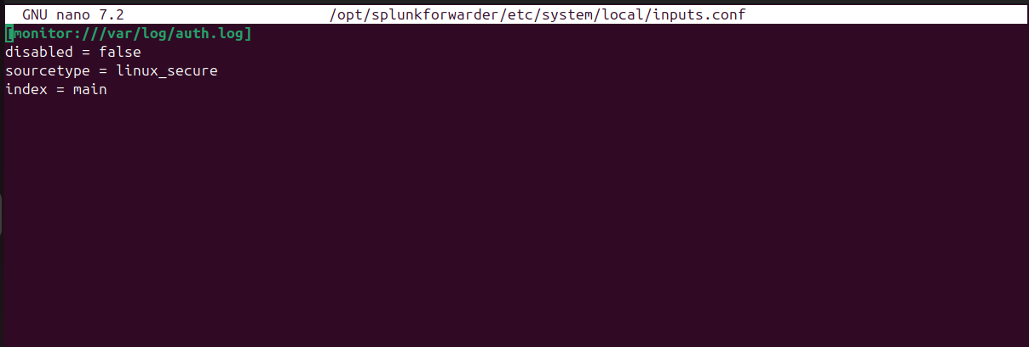

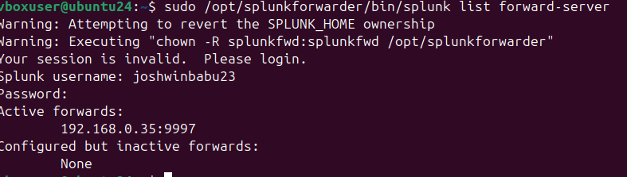

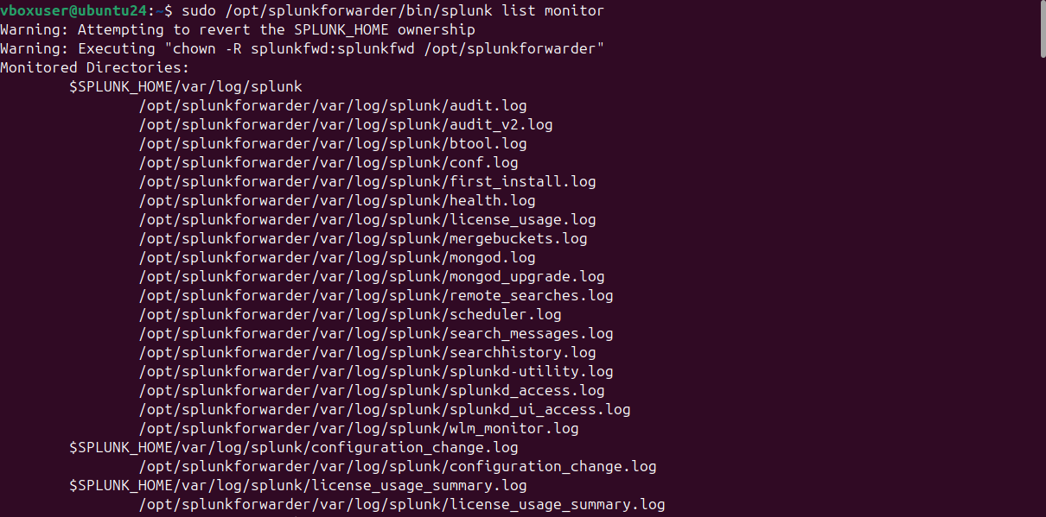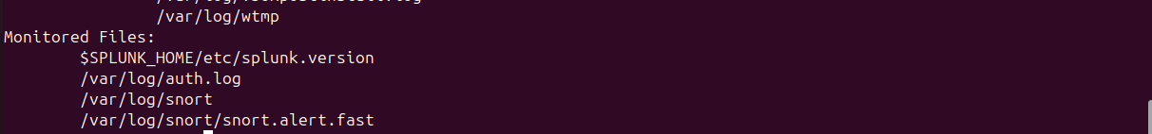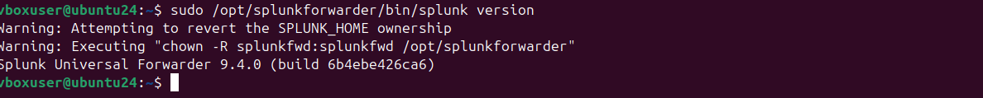

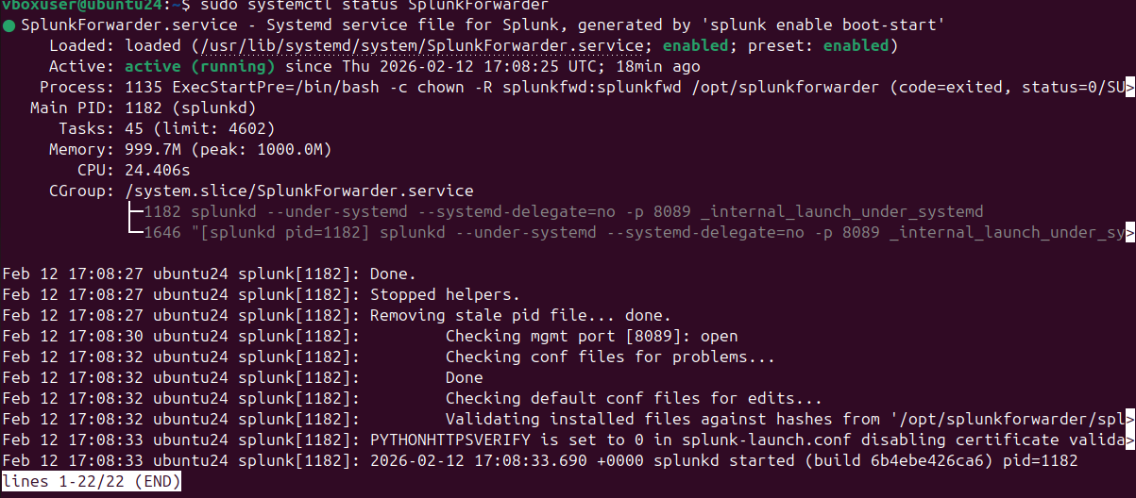

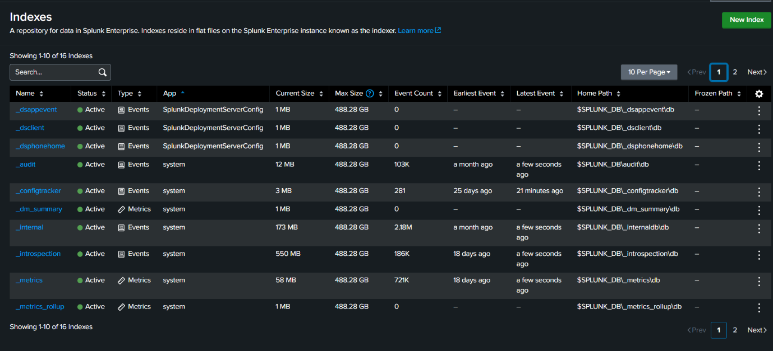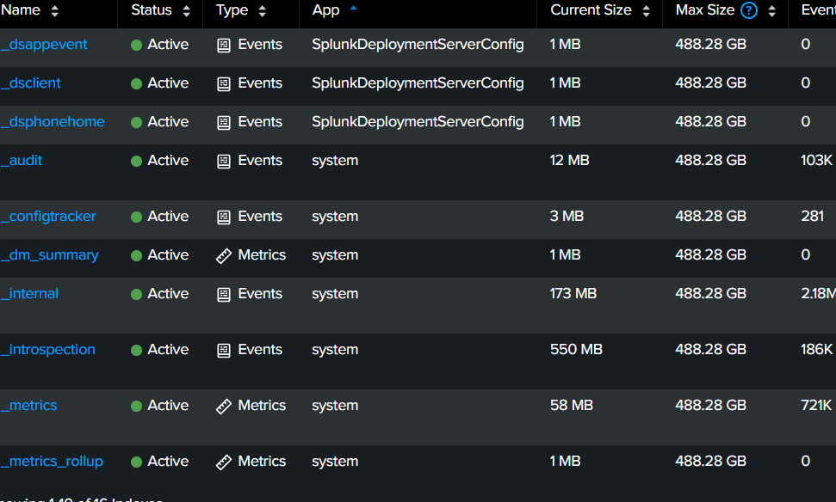

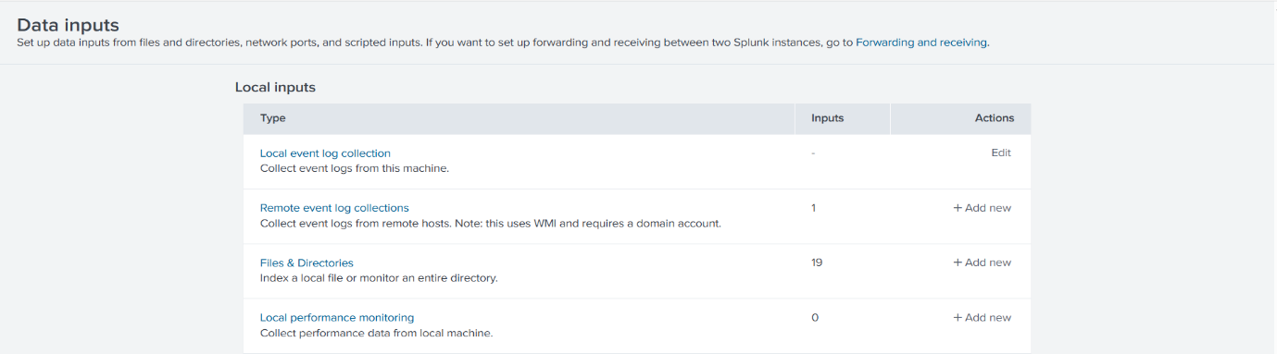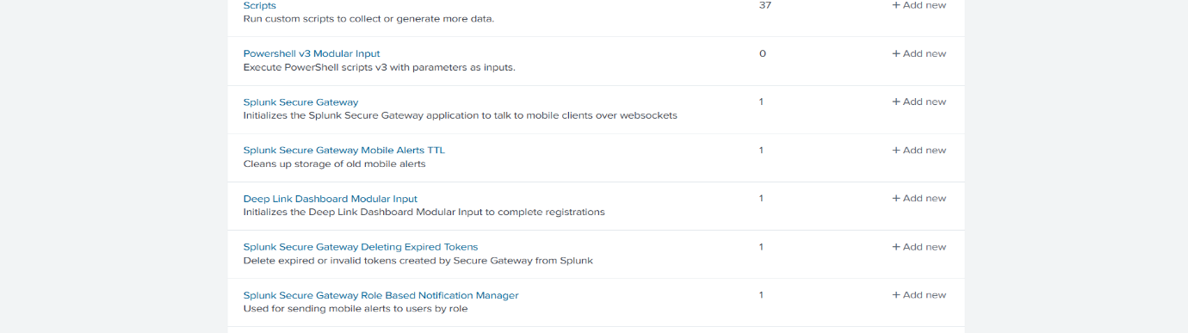



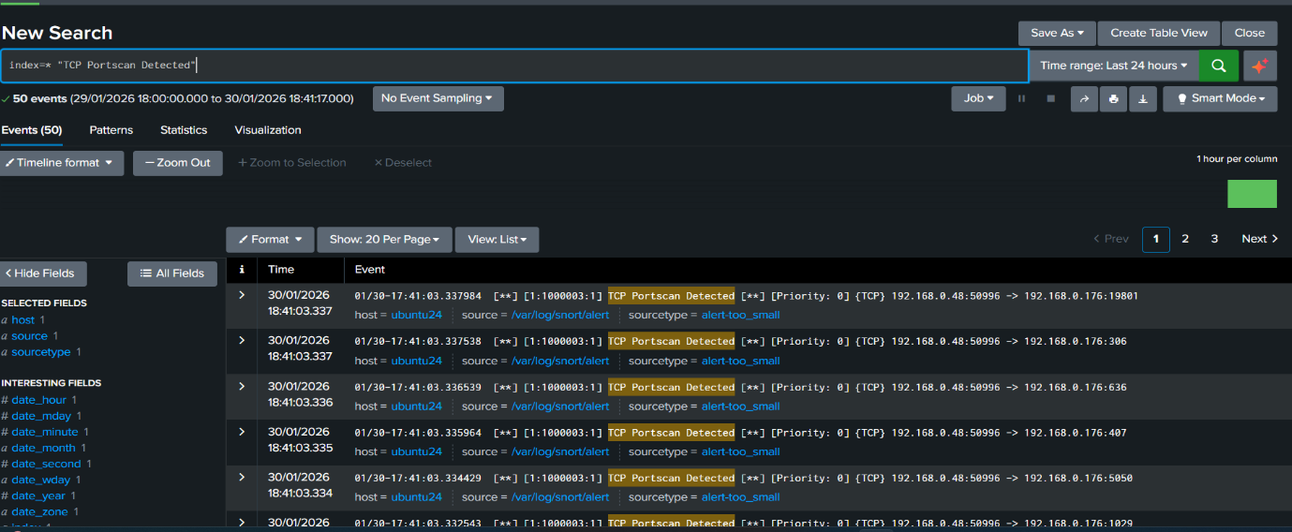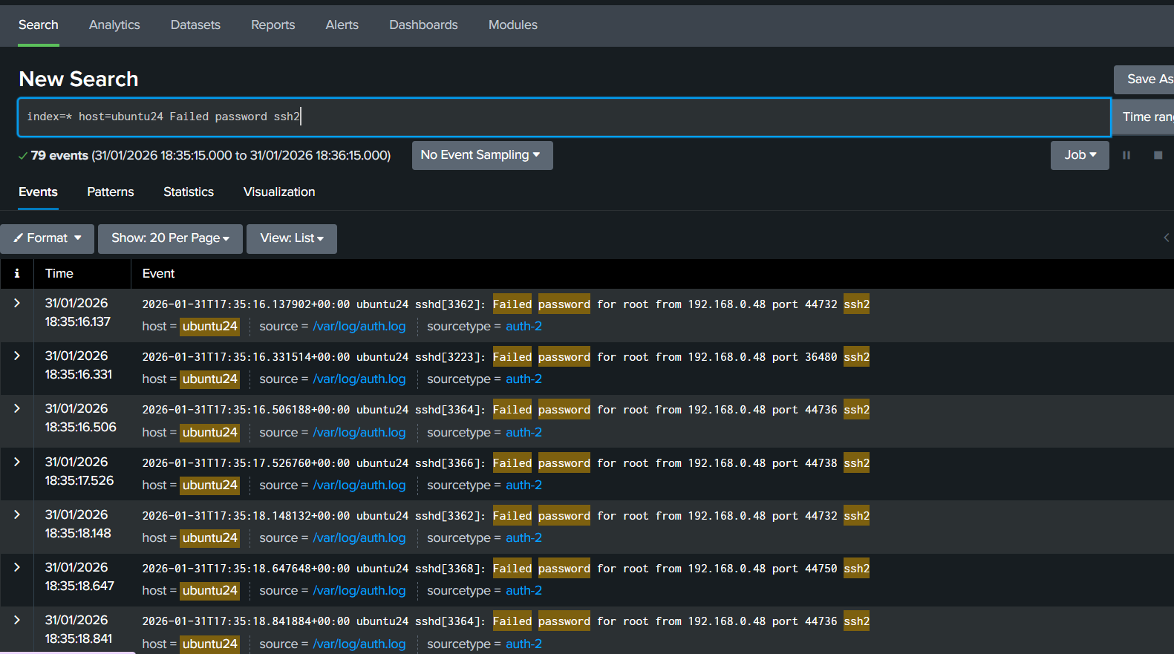

**Appendix C – Attack Commands**

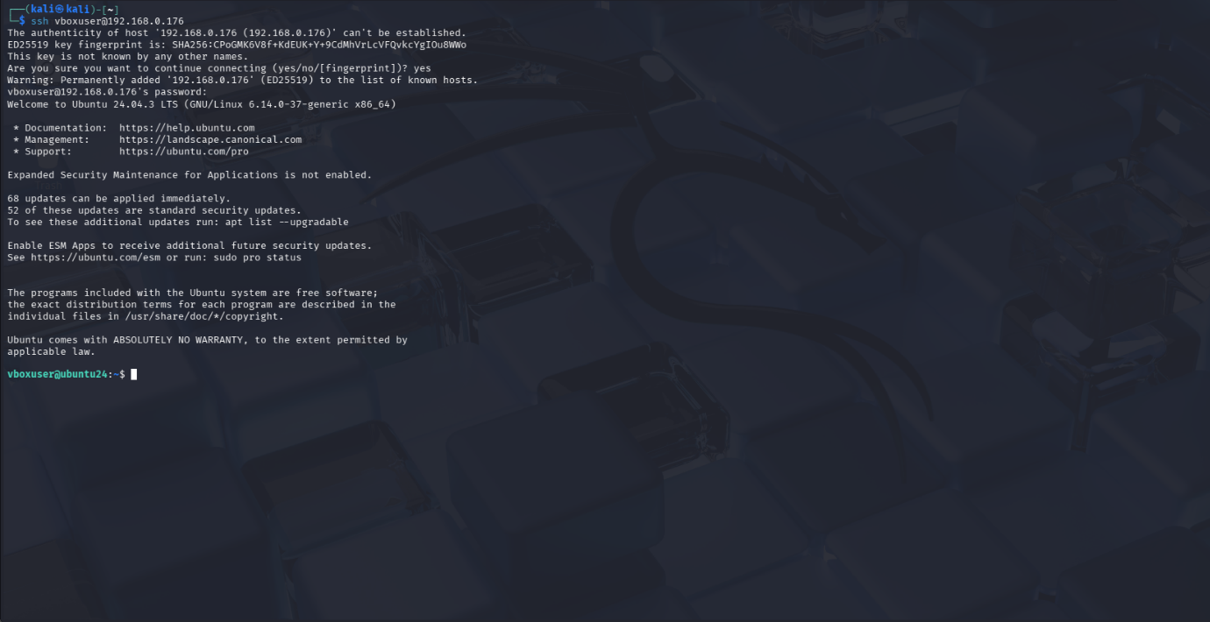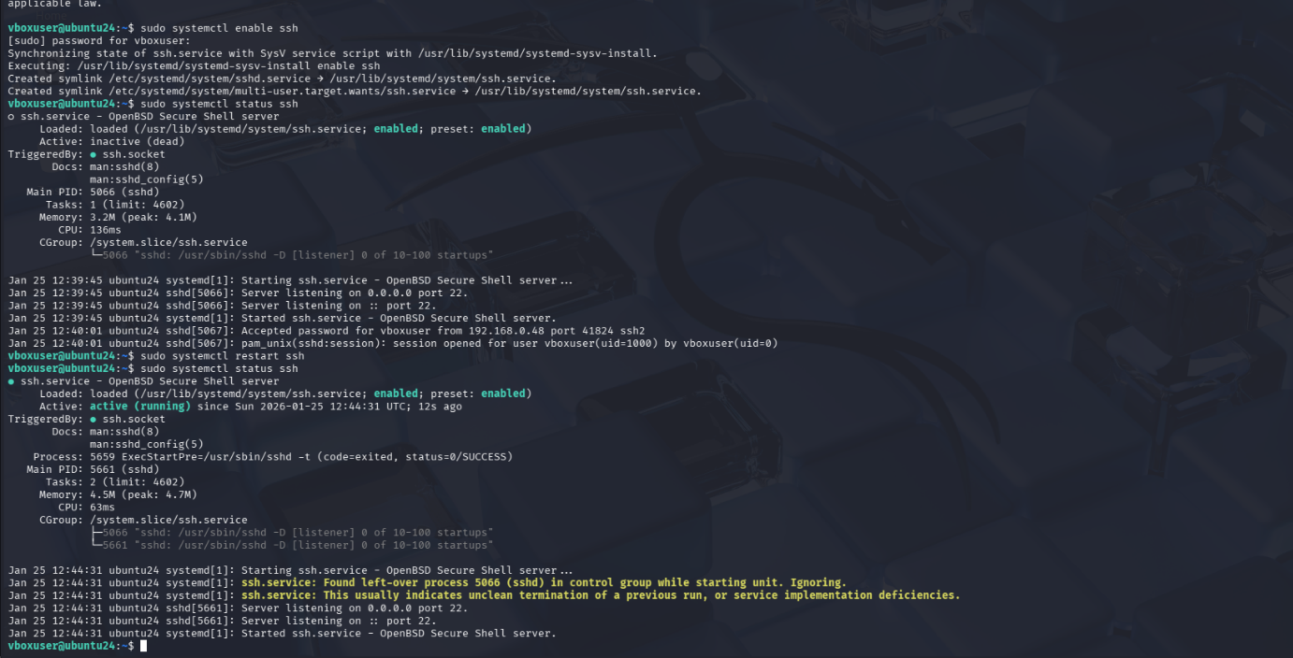





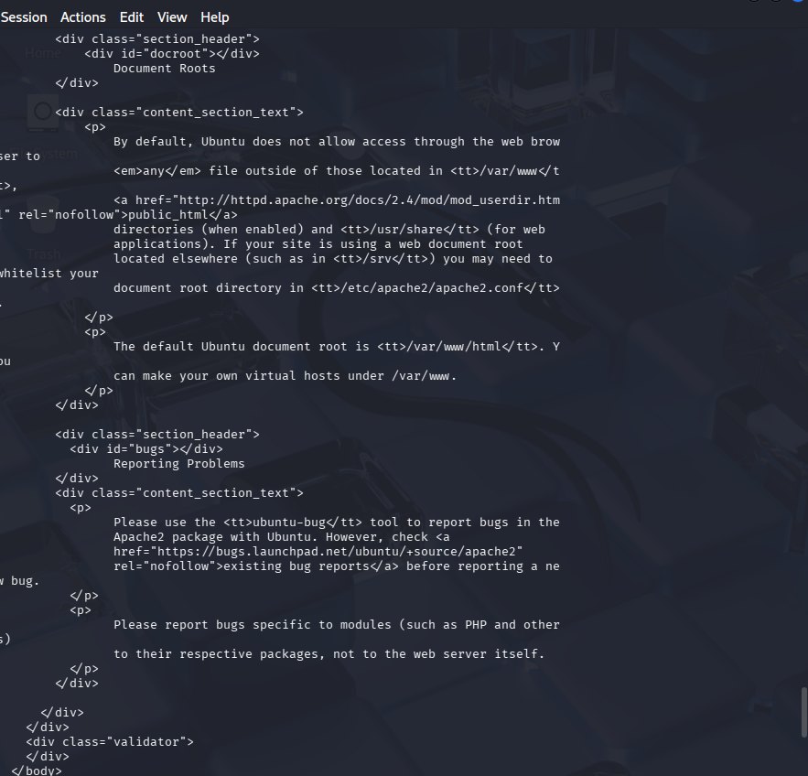

**APPENDIX D – SCREENSHOTS**

## **D1. Network Scanning Detection Screenshots**





## **D2. SSH Brute‑Force Detection Screenshots**







**D3. Privilege Escalation Detection Screenshots**







**D3. Web-Based Detection Screenshots**





